Name ___________________________

Math 8: What is a Function?
Directions: Fill in the blanks below as you watch the video.
What is a function?
- A function is a relation that relates each x value with _______________ y value.

- In other words, the x's ____________ repeat!

Example: {(-2, 1), (0, 3), (3, 6), (-5, -2)}
Is this relation a function? _______

Are the relations below functions?
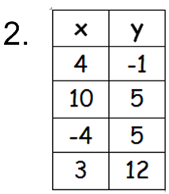  _______  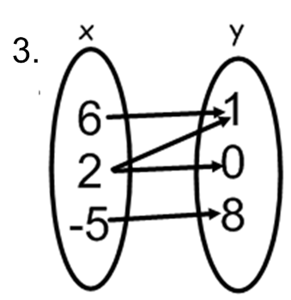 _________ | 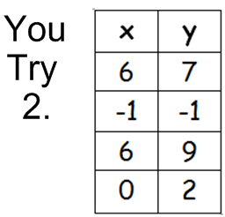  ________  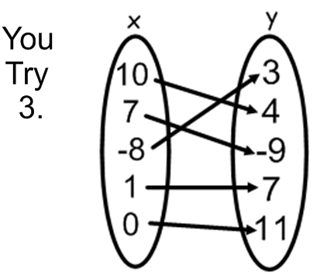 ________
Vertical Line Test:
- If a vertical line intersects the relation's graph ________ _________ one time, then the relation is NOT a function.
- If a vertical line intersects the relation's graph ________ one time, then the relation IS a function.
Are the relations below functions?
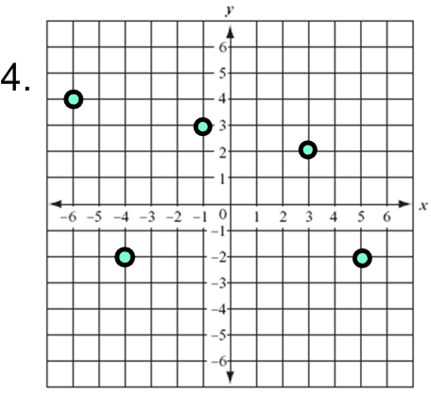  __________  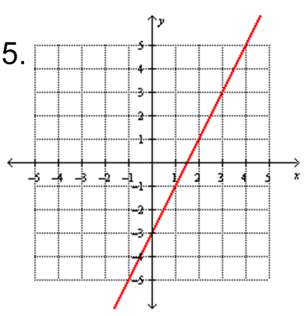  __________  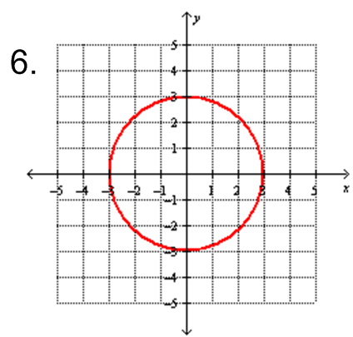  __________ | You Try 4.  You Try 5.  You Try 6. | 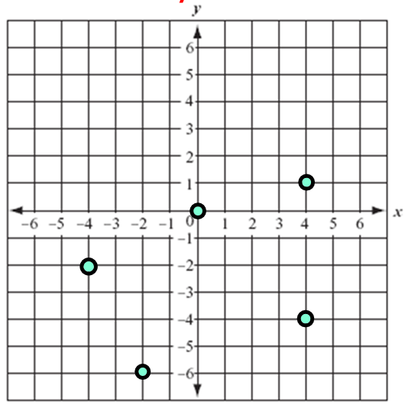  __________  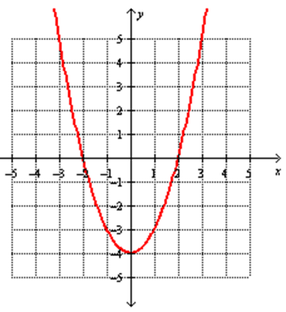  __________  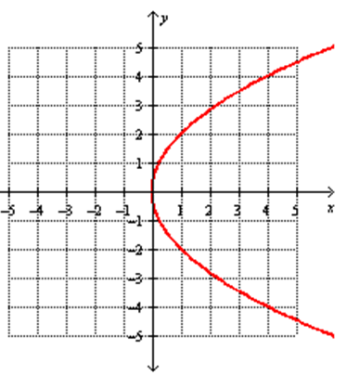  __________
What did we learn?
- A function is a special type of relation that relates each x value with only one y value.
- In other words, the x's DO NOT repeat!
- We can use the Vertical Line Test to determine if a graph is a function.
- If a vertical line intersects the relation's graph more than one time, then the relation is NOT a function.
- If a vertical line intersects the relation's graph only one time, then the relation
IS a function.

