The Distance Formula
Name_____________________
The Pythagorean Theorem
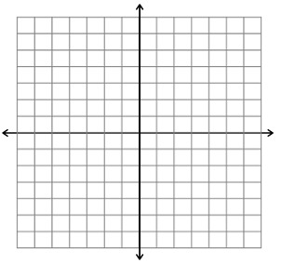
- Find the distance between the points (1,2) and (4,6) by using the Pythagorean Theorem.

Connecting the Pythagorean Theorem to the Distance Formula
- What is the distance formula?

- Find the distance between the points (1,2) and (4,6) by using the distance formula

- Explain how the Distance Formula and the Pythagorean Theorem are related.

Examples of using the Distance Formula
- Find the distance between the following points
  - (3,6) and (-2, 5)

  - (7,-9) and (-2,-1)
Independent Practice
- Find the distance between the following points
  - (3,5) and (6,7)

  - (-4, 6) and (7,-1)

  - (-5, -2) and (-3, 2)

  - (-12, -9) and (-6, -3)

