Experiencing M.C. Escher: Tessellation and Art
Maurits Cornelis Escher was a Dutch graphic artist who made mathematically-inspired woodcuts, lithographs, and mezzotints (print made from an engraved copper or steel plate) His creations often include tessellations (an arrangement of shapes closely fitted together, especially of polygons in a repeated pattern without gaps or overlapping) and other Mathematical patterns.
"I try in my prints to testify that we live in a beautiful and orderly world, and not in a formless chaos, as it sometimes seems." – M.C. Escher
Few examples of his work:
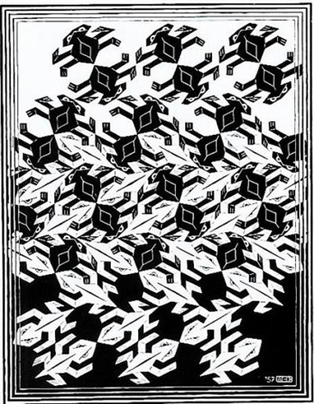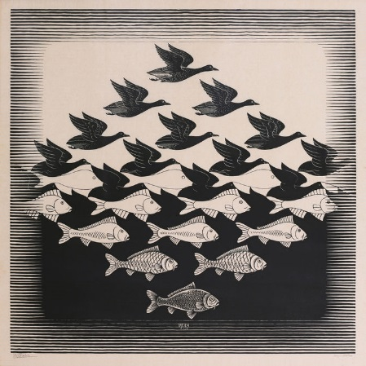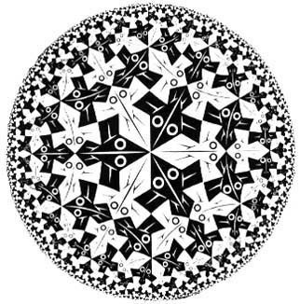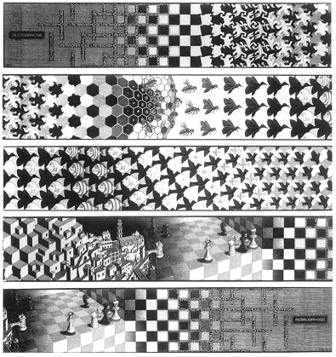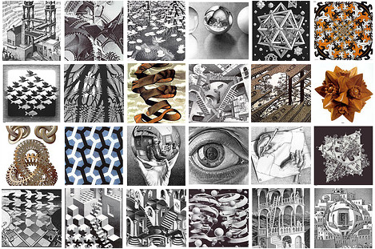

Using only a geometric shape and a series of transformations, create a print similar to those created by M. C. Escher.

