Name:______________________________________ Core: _________ Date: ____________________
Review of linear equations/functions
- What is the rate of change for this linear function {(0, 3), (1, 6), (2, 9), (3, 12)}?

- Graph: a) y = – 3x - 5 (use rise/run and y-intercept)

b) 3x + 6y = 36 (use x-intercept and y-intercept)

- Find the slope of the lines passing through the points:
a) (6, 2) and (-2, -3)
b) (-7, 4) and (0, -10)
- Find the equation of the lines:
a) 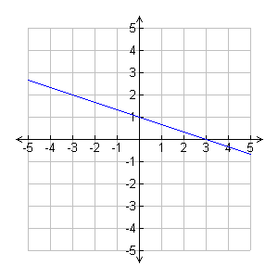 b) 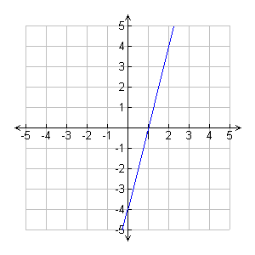

- Cyndi is starting a business tutoring students in math. She rents an office for $400 per month and charges $50 per hour per student. If she has 15 students for one hour per week, how much profit does she make in a month? (assume 4 weeks per month)

- Find the slope and y-intercept of the line represented by each equation:
y = 6x + 3 slope ________ y-intercept _______
y = 7 – 9x slope ________ y-intercept _______

- At noon, the temperature is 30° F.
For the next several hours, the temperature falls by an average of 3° F an hour.
What is the rate of change and initial value?
Write an equation for the temperature T, n hours after noon.

- Transform the equation 33 + 9x = 11y in
a) slope-intercept form
b) standard form

