 | Problem 1 | Problem 2 | Gridded Response
Monday | 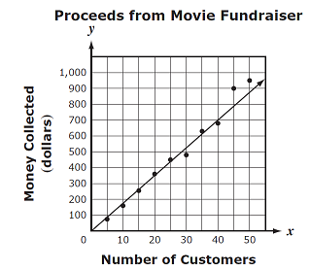  Based on the graph below, what would the slope of the line represent? | 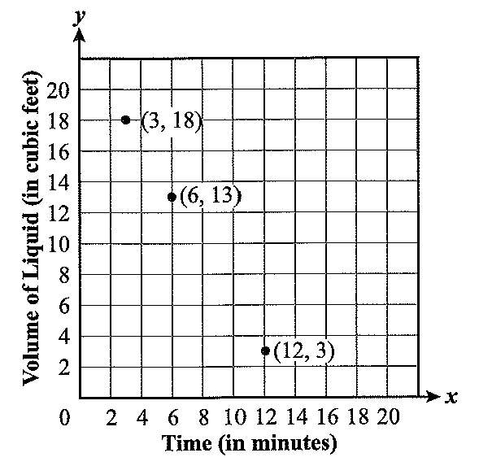  The pool in the backyard is drained at a constant rate. The volume of the water remaining was recorded in the graph below. At what rate, in cubic feet per minute, is the volume of the water changing? Express your answer as a decimal to the nearest tenth. | Problem 2  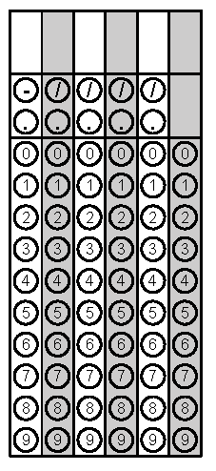
Tuesday | MillyCakes sells chocolate pies for $6.99 and fruit pies for $10.99. She sold 36 pies on Friday and collected $331.64. How many chocolate pies did she sell? | For what value of r will make the table represent an exponential function?  x y  0 3  1 6  2 r | Problem 1
Wednesday | Meg plotted the two points  (20, 75) and (45, 150) on a graph. What is the x-coordinate of the x-intercept of the line that contains the two points? | The legs of a right triangle have lengths of x + 2 and x + 6. The hypotenuse has a length of 2x. What is the perimeter of the triangle? | Problem 1
Thursday | Simplify to an expression with only positive exponents.  $$\frac{{(x^{-2}y^{10})}^{2}}{x^{5}y^{-3}}$$ | Zach launched a water balloon in the air. The time vs. distance of the balloon’s path is shown in the graph. How long did it take the balloon to hit the ground? | Problem 2
Friday | Danielle has taken 4 science quizzes. Her scores were 72, 80, 84, and 92. What minimum score must she get on her next quiz to have an average score of at least 84? | The height (h) in feet of a ball t seconds after being dropped is given by the function  h(t) = 9 – 16t². From what height in feet was the ball initially dropped? | Problem 2
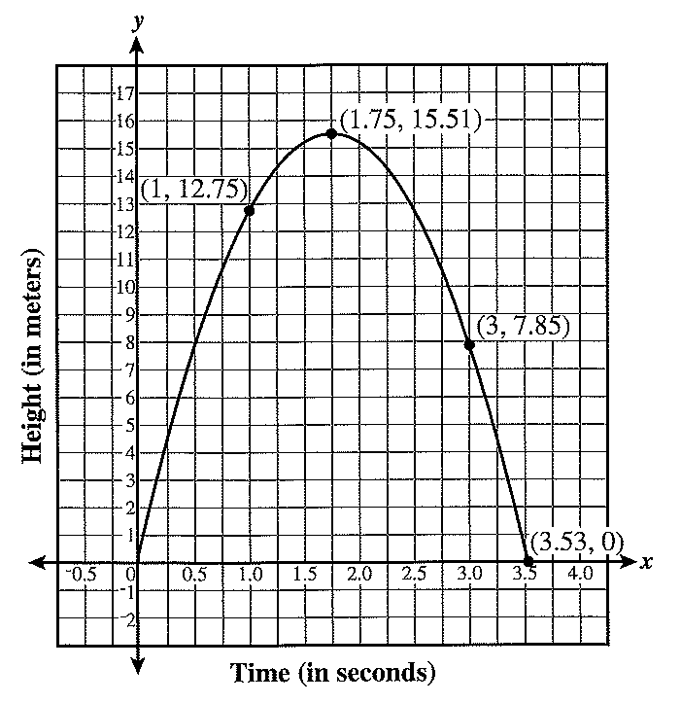
Questions adapted from Score21 and SchoolNet

