 | Problem 1 | Problem 2 | Gridded Response
Monday | 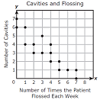  A dentist made a scatterplot to show the number of cavities his patients have as it relates to the number of times they flossed their teeth in a week. Estimate a line of fit and determine, on average, the number of cavities for a patient who flossed 4 times each week. | At Cook-Out four burgers and 3 fries cost $26.50. Five burgers and five fries cost $36.25. What is the total cost of 2 burgers and one fry? | Problem 2  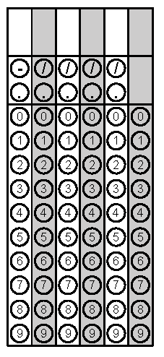
Tuesday | Michael simplified the following expression:  (x⁴y⁹z⁻³)(x⁻²y⁻¹⁰z⁷). If he writes his answer in the form xªy^{b}z^{c}, what is the value of b, the exponent on the y? | A line segment has endpoints  D(4, 2) and M(10, 16). The point H is the midpoint of $\overline{DM.}$ What is the equation of the line perpendicular to $\overline{DM}$ and passing through point H? | Problem 1
Wednesday | Archimedes pulled the plug in his bathtub and it started to drain. The amount of water in his tub is expressed by the function  L(t) = -5t² – 8t + 120 where L is the number of liters in the tub and t is the time in minutes since the plug was pulled. How long, to the nearest tenth of a minute, will it take the tub to drain completely? | Sonja translated the graph of a function 3 units left and wrote the equation of the new graph as  f(x) = (x + 3)² – 5. What was the equation of the original function? | Problem 1
Thursday | Ranger Road Middle School has a gym in the shape of a rectangle. Its floor has a length of (x + 4) meters and a width of (3x – 2) meters. Write a simplified expression representing the area in square meters of the gym floor. | Ramar walked 2 miles in 25 minutes. Shelley walked 5280 yards in 30 minutes. In miles per hour, how much faster did Shelley walk than Ramar? | Problem 2
Friday | Given the data in the table below, which type of model would best describe the data? Choose from linear, quadratic or exponential. | Using the model and information from problem #1, predict the number of people who got emails at the end of the 5th day. | Problem 2
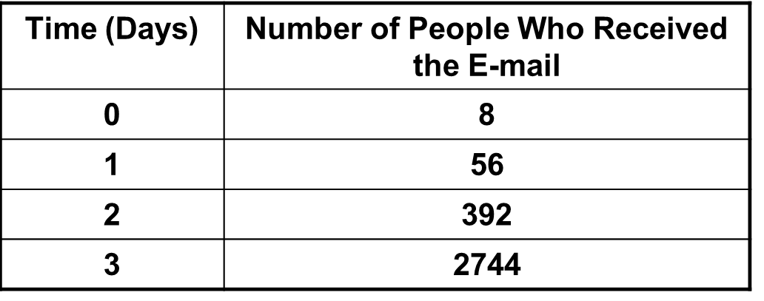
Questions adapted from Score21 and SchoolNet

