 | Problem 1 | Problem 2 | Gridded Response
Monday | 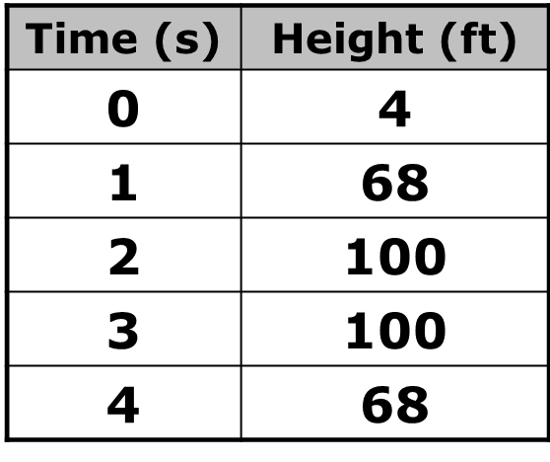  Height of Golf Ball  Given the data in the table below, which type of model would best describe the data? Choose from linear, quadratic or exponential. | Using the model and information from problem #1, predict the height of the golf ball after five seconds. | Problem 2  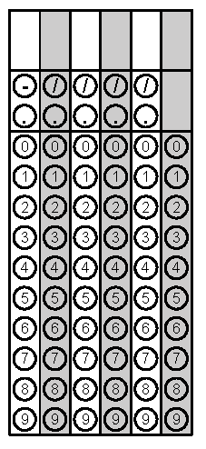
Tuesday | At a BBQ, Daryll is buying dinner for his family. One hotdog meal and one hamburger meal is $11. One hotdog meal and two hamburger meals is $18. How much money would Daryll spend if he bought 3 hotdog meals and 4 hamburger meals? | The cost of renting a car for one day includes a flat fee plus a charge for each mile driven. If 107 miles costs $97.15 and 127 miles costs $106.15, what is the flat fee charge for the car rental? | Problem 1
Wednesday | The weekly profit in dollars of a small business that produces homemade BBQ sauce is  P(x) = -0.4x² + 40x – 360 where x is equal to the number of jars produced and sold. How many jars of BBQ sauce must be produced and sold to get the most profit? Round your answer to the nearest whole jar if necessary. | 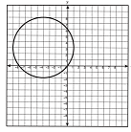  The circle shown passes through points (-4, 8), (-4, -2), (-9, 3) and (1, 3). The center of the circle is at what point? | Problem 1
Thursday | Write ${(\sqrt[3]{4x})}^{2}$ in exponential form. | A $1000 is left in a savings account for ten years earning 7% interest compounded monthly. What is the balance of the account at the end of 10 years? | Problem 2
Friday | The length of a rectangle is 6 inches more than 3 times its width. If the perimeter is 84 inches, what are the dimensions of the rectangle? | A Baking Club sells cookie bags and drinks during basketball games.  - 80 cookie bags and 140 drinks is $520  - 160 cookie bags and 90 drinks is $660  How much does each bag of cookies cost? Express your answer in dollars and cents. | Problem 2
Questions adapted from Score21 and SchoolNet

