 | Problem 1 | Problem 2 | Gridded Response
Monday | Tiffany wants to spend at most $30 for a bouquet of roses and carnations. Carnations are $3 each and roses are $5 each. She wants her bouquet to have at least 6 flowers. Write a system of inequalities to represent this situation. | A projectile is launched at a speed of 40m per second from a 49m tall platform. The equation for the objects height at S at time t seconds is S(t) = -4.9t² + 40t + 49, where S is in meters. How long will it take for the projectile to reach its maximum height? Round your answer to the nearest tenth of a second if necessary. | Problem 2  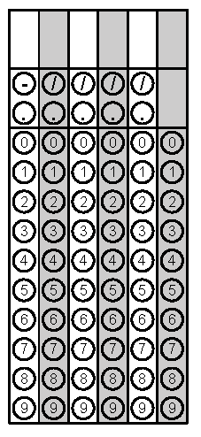
Tuesday | 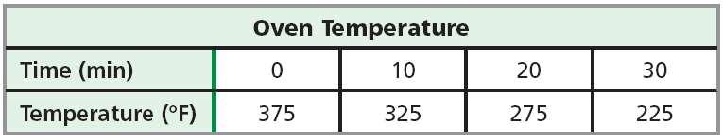  Given the data in the table below, which type of model would best describe the data? Choose from linear, quadratic or exponential. | Using the model and information from problem #1, predict the temperature of the oven after 1 hour. | Problem 1
Wednesday | Fia and Wesley are saving to buy a car. Fia has $750 saved and is adding $30 a week to the account. Wesley has $1200 saved and is adding $20 a week. How many weeks until they both have the same amount saved? | 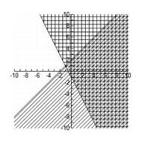  A system of inequalities has been graded on the plane below. Use a highlighter to indicate the answers to the system. | Problem 1
Thursday | A suryvey of 4,500 people was given. The results of a survey of favorite colors are shown below in the relative frequency table. How many females stated that red was their favorite? | A line segment has endpoints  B(-6, 4) and Z(-8, 6). The point M is the midpoint of line$\overline{BZ}$. What is the equation of the line perpendicular to $\overline{BZ}$ passing through M? | Problem 2
Friday | The length of each side of a square tissue box is represented by the expression 5w². The volume of the box in cubic inches is (5w²)³. Write the volume of the box in simplified form. | A NC sweet potato farmer knows that the number of sweet potato harvested varies directly with the number of plants grown. Last year the farmer harvested 189 potatoes from 9 plants. If he grows 14 plants this year, how many potatoes can he expect to have? | Problem 2
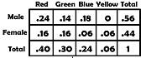
Questions adapted from Score21 and SchoolNet

