 | Problem 1 | Problem 2 | Gridded Response
Monday | 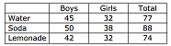  Mr. Wilson took data on the types of drinks the 8th graders drank regularly at lunch. What percent of boys drink water on a regular basis? | Dr. Knox wants to combine a 20% alcohol solution with a 60% solution to form 200 mL of a 45% solution. How much of the 60% solution should he use? | Problem 2  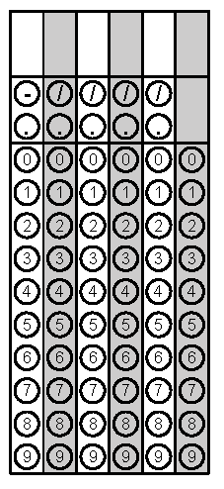
Tuesday | The average daily high temperature for the month of April in Raleigh is approximated by the function f(n) = 0.2n + 80 where n is the day of the month. April has 30 days. What was the maximum high temperature that occurred on April 17th? | McCaslin Cycling charges a $50 start-up fee plus $2.00 per class. Cycles4Life charges $5 per class with no start-up fee. Write a function representing the difference in cost between McCaslin Cycling and Cyles4Life. | Problem 1
Wednesday | Vjay spends $16 on notebooks and pencils. Notebooks cost $3.00 and pencils $0.50. If Vjay bought 12 items, how many notebooks did he buy? | Simplify.  $$\frac{1}{2}x\left(4x-6\right)+3(x^{2}-1)$$ | Problem 1
Thursday | A rocket carrying fireworks is launched for a bridge 80 feet above a lake. The rocket’s height above the surface is given by the equation h = -16t² + 64t + 80. To the nearest second, how long did the rocket take to hit the lake? | Using the same situation from problem #1, what was the highest point of the firework rocket’s journey? Round your answer to the nearest whole number if necessary. | Problem 2
Friday | You want to open a checking account at the local bank. You are given two options. Standard checking is $6 a month and $0.25 for each check you write. Select Checking is $4.50 a month and $0.50 per check. Write a system of equations that can be used to determine the number of checks, c, that must be written in order for the total charges, t, for the 2 accounts to be the same. | Solve the system in #1 to find the number of checks written when both accounts charges are the same. | Problem 2
Questions adapted from Score21 and SchoolNet

