 | Problem 1 | Problem 2 | Gridded Response
Monday | Alan is standing on a hill 80 ft. high. He throws a ball upward with an initial velocity of 64 feet per second. If the height of the ball is modeled by the function  h(t) = -16t² + 64t + 80, what was the maximum height the ball reached? | The longer leg of a right triangle is 2 cm more than the shorter leg. The hypotenuse is 4 cm more than the shorter leg. Find the length of the shorter leg. | Problem 2  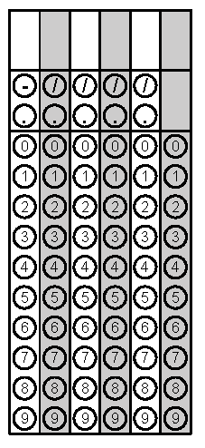
Tuesday | Forest Middle School Band held a bake sale. The number of cupcakes sold was four more than twice the number of cookies sold. The band sold 52 cupcakes and cookies. If each cupcake was $4.00, how much money did they make on cupcakes? | 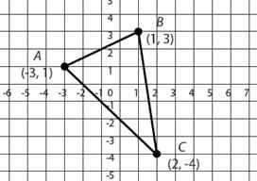  What is the equation of the line that is perpendicular to side AB and goes through the midpoint of side AB? | Problem 1
Wednesday | What is the value of f($\frac{2}{3}$) when  f(x) = x² + 3x – 2? Write your answer as a fraction in lowest terms if necessary. | Surbi bought a car for $25,000. The price of the car depreciated each year and the value of the car is modeled by the function f(x) = 25,000(.85)^{x}. By what percent does the car value depreciate each year? | Problem 1
Thursday | The product of two consecutive odd integers is 99. What is the sum of the integers? | During a basketball game, a concession stand only sells nachos and hotdogs. Nachos are $2.50 and hot dogs are $2.00. If the concession stand sold 144 items and made $336, how many nachos were sold? | Problem 2
Friday | Webb invested $1750 in an account earning 13.5% interest compounded monthly for a two year period. What is the balance, to the nearest dollar, at the end of the two years? Use 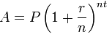. | According to the graph below, on average how long does it take water to evaporate through an opening 8 cm²? | Problem 2
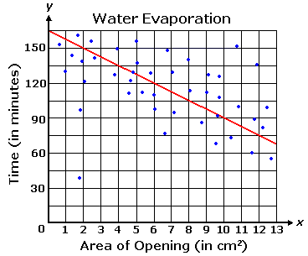
Questions adapted from Score21 and SchoolNet

