 | Problem 1 | Problem 2 | Gridded Response
Monday | The sum of an integer and three more than five times itself is 111. Find the integer. | Given the system of equations below, find the value of x + y.  3y + 2x = 6  5y – 2x = 10 | Problem 2  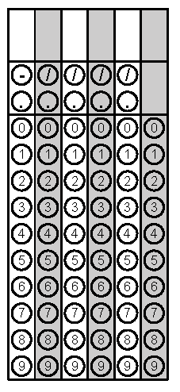
Tuesday | Ms. Keener’s science class has a 25% and 50% acid solution. How much of the 25% solution should be used to form 200 mL of a 35% acid solution? | 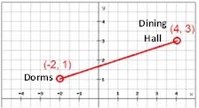  Bathrooms are being built halfway between the Dorms and the Dining Hall on the map below. Where on the coordinate plane should the bathrooms appear? | Problem 1
Wednesday | When put on a coordinate plane, Wade Avenue has the equation  y = (1/3)x – 4. Blue Ridge Road crosses Wade avenue at a 90º angle and goes through point  (-2 2). Using this information, write an equation that would represent Blue Ridge Road. | Ms. Kelly discovered a new strain of bacteria. The bacteria culture initially contained 1000 bacteria and they are doubling every half hour. Write an equation to illustrate this situation and determine how many bacteria there will be in 5 hours. | Problem 1
Thursday | Charlotte and Oskar are playing a game. Each person starts with 30 points. At the end of each turn Charlotte’s points doubled and Oskar’s points increased by 150. At the start of what turn will Charlotte have more points that Oskar? | Tony is starting the 2015 Sit-Up Challenge. The plan starts by doing 2 sit-ups the first day. He then plans to triple the sit-ups every week. If he keeps this routine consistent, how many sit-ups will Tony be completing during the 5th week? | Problem 2
Friday | Zach’s age is 3 times Lynde’s age. Twice Zach’s age is equal to four times Lynde’s age plus 20. How old is Zach? | Becky is comparing two local yoga programs. Rolesville Yoga charges $3 a week and a registration fee of $12. Wake Forest Yoga charges $4 a week with a registration fee of $5. After how many weeks will the two yoga programs charge the same amount? | Problem 2
Questions adapted from Score21 and SchoolNet

