 | Problem 1 | Problem 2 | Gridded Response
Monday | 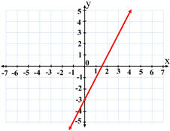  The graph of y ≥ 2x – 3 is shown on the coordinate plane below. Which half-plane, I or II, should be shaded?  I  II | What is the value for x in the proportion?  $$\frac{x+8}{5x-2}= \frac{3}{8}$$ | Problem 2  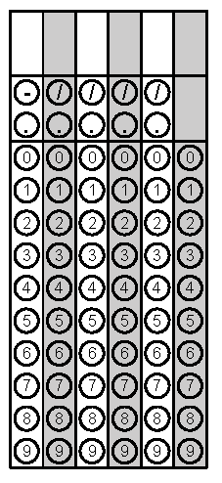
Tuesday | Charlotte is located at (-1, -3) on a coordinate plane. Raleigh is located at (4, 9). If a train traveling in a straight line stops halfway for a break, what is the  x-coordinate of the break stopping location? | The area of a rectangle is given by the expression d² – 49. Circle which rectangle below this area expression represents. Prove your answer.  d - 7  d - 7  d - 7  d + 7 | Problem 1
Wednesday | In 1995 there were 85 rabbits in Central park. The population increased by 15% each year. If the rabbit population continued to grow at the same rate each year, how many rabbits are in Central Park in 2015? Round your answer to the nearest whole rabbit if necessary. | Between 1990 and 2001, the number of visits (in millions) to Glacier National Park can be modeled by the function  y = -10.4x² + 132x + 332. If x is the number of years since 1990, in what year had 750 million people visited the park? | Problem 1
Thursday | Highlight which function in the table below has the greatest rate of change.  x f(x) g(x) h(x)  -2 3 -6 -4  -1 4 -3 -2  1 6 3 2  2 7 6 4 | Based on the graph of  y = x² – 2x – 3, what is the positive solution?  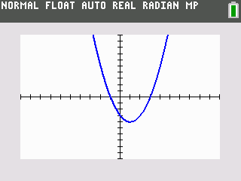 | Problem 2
Friday | Ms. Skipper asks her students to translate the graph of the function shown in the box 4 units to the right. Write a function to represent this translated function.  f(x) = x² + 7 | Coach Rodriquez drew his football team’s next play on a coordinate grid. He placed Cam at (1,3) who will be passing the ball to Greg at (-6, 3). What is the distance, in yards, of the pass from Cam to Greg? | Problem 2
Questions adapted from Score21 and SchoolNet

