 | Problem 1 | Problem 2 | Gridded Response
Monday | Erin’s car breaks down on a highway. Erin estimates that she is 20 to 30 miles from the nearest car repair shop. She calls a car shop that charges a fee of $80 plus $2 per mile to tow a car. If Erin uses this company, what is the range of possible values for the amount of money, m, she will have to pay? | Maureen used a quadratic function to solve a problem. The factored form of the function is shown below. What is the positive solution to the problem?  (4x + 3)(6x – 3) = 0 | Problem 2  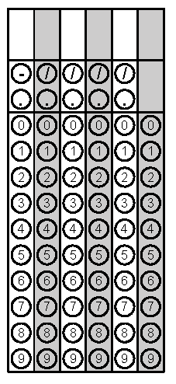
Tuesday | Mary is enrolled in a communications class that is practicing public speaking. Each week she has to give a longer speech than the week before. The length of Mary’s speeches each week is recorded in the table. If the trend continues, what week will she give a 12 minute speech?  Week # 3 4 5 6  Length (seconds) 150 180 210 240 | What is ${(25a)}^{\frac{3}{2}}$ written in radical form? | Problem 1
Wednesday | The cost of renting a van for one day includes a flat rental fee plus a charge for each mile the van is driven while it is rented. A van that is driven 107 miles cost $97.15. A van that is driven 127 miles costs $106.15. What is the flat rental fee? | An in ground farm sprinkler sprays water with an initial velocity of 65 feet per second. How long will the water be in the air before hitting the ground? Use h = -16t² +vt + s and round your answer to the nearest second if necessary. | Problem 1
Thursday | What would be the best estimate of the number of debates you could win if you practiced 6 hours a week? | A ball is dropped from a height of 10 feet. On each bounce, the ball reaches 80% of the height of the previous bounce. After what bounce will the ball rise to an approximate height of 1 ft.? Round your answer to the nearest whole number if necessary. | Problem 2
Friday | Write $\sqrt[7]{x^{2}}$ in exponential form. | If you graphed the quadratic function in the box below, what would be the value of the y-intercept?  f(x) = x² – 6x + 5 | Problem 2
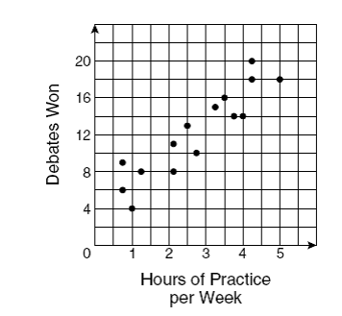
Questions adapted from Score21 and SchoolNet

