 | Problem 1 | Problem 2 | Gridded Response
Monday | The perimeter of the figure below is 9b² – 2ab + 12a². What is the length of the missing side?  9ab + 8a²  4a² – 4ab  7b² – 2ab  ? | What is the slope of the line that is perpendicular to the line containing the points (-2, 5) and  (-11, 15)? Write your answer as a fraction in lowest terms if necessary. | Problem 2  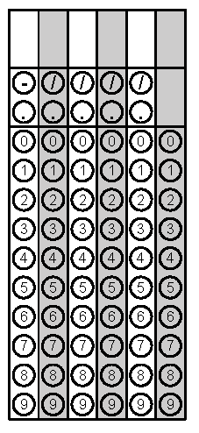
Tuesday | The first six numbers of a pattern are shown below. If the pattern continues, what would be the 9th term?  $\frac{1}{3}$, $\frac{4}{3}$, 3, $\frac{16}{3}$, $\frac{25}{3}$, 12……… | A rectangular blacktop with a length of 5x and a width of 3x has been erected inside a rectangular field that has a length of 12x and a width of 7x. What is the area of the part of the field that is not blacktop? | Problem 1
Wednesday | Determine the value of h(5) when  $h\left(s\right)=2\left|-\frac{2}{3}s-6\right|.$ Write your answer as a fraction in lowest terms if necessary. | Ross has (8x – 5) tickets for Chuck E Cheese. He is going to play today and wants to buy a prize that is (15x + 1) tickets. How many tickets must he win to have enough tickets to buy the prize? | Problem 1
Thursday | Bob mowed (2x² + 5x – 3) yards on Monday, (4x – 7) yards on Tuesday, and (3x² + 10) yards on Wednesday. How many yards did he mow in the three days? | 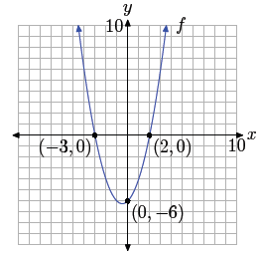  What is the absolute value of the difference in the x-values of the roots of the quadratic function graphed below? | Problem 2
Friday | Three identical tennis balls, with a diameter of 8 centimeters are stacked in a cylindrical container. Find the volume of the container to the nearest cubic centimeter. | The charity that you volunteer for is selling potted daffodils in the spring to raise money. The charity has spent $250 on supplies and plans to sell them for $5 each. What is the minimum number of daffodils the charity needs to sell in order for the profit to be positive? | Problem 2
Questions adapted from Score21 and SchoolNet

