 | Problem 1 | Problem 2 | Gridded Response
Monday | Create a time-distance graph that illustrates the following situation:  Mickey went for a jog. At the end of his road he bumped into a friend and his pace slowed. They stopped for a little time to say goodbye. When Mickey left his friend, he walked quickly back home. | Mr. Bricker teaches at a martial arts studio. He charges a one-time process fee of $5 and the cost of the classes is displayed in the table below. Based on the information, what will be the total cost to take 10 classes?  Cost of Classes  (Not including one-time fee.)  Number of Classes Cost of Classes  1 $15.00  2 $27.00  3 $39.00  4 $51.00 | Problem 2  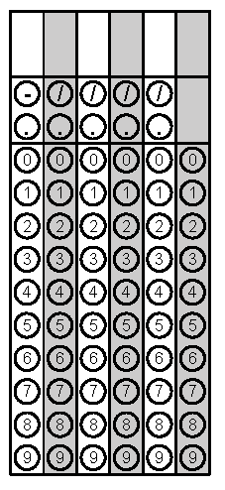
Tuesday | Kelly plans to put her graduation money into an account and leave it there for 4 years while she goes to college. She receives $750 in graduation money that she puts into an account that earns 4.25% interest compounded semi-annually. How much will be in Kelly’s account at the end of four years? Round answer to nearest dollar if necessary. | Jessica loves to babysit and the amount she earns can be modeled with the equation y = 7.50x where y is her total earnings and x is the number of hours she babysits.  a. What does 7.50 represent?  b. Where would the y-intercept be located and why?  c. Is this a linear function? | Problem 1
Wednesday | Judd and three friends went golfing. Two of the friends rented clubs for $6 each. (Judd and the other friend had their own clubs.) The total cost of the rented clubs and green fees for each person was $76. What was the cost of the green fee for each person? Round answer to nearest hundredth if necessary. | Based on the graph of the final exam scores, which interval contains the median of the data? Explain.  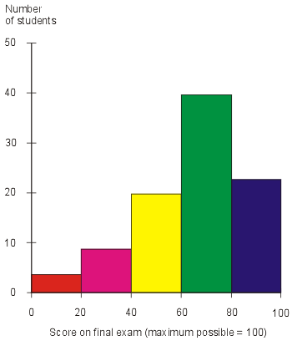 | Problem 1
Thursday | Express the perimeter of the triangle as a polynomial.  2y - 3x - 3  9x - 3y + 2  12 + 5x + 7y | The number of miles an Uber Driver varies directly with the number of gallons of gas in the tank of the car. The driver was able to drive 396 miles with 19 gallons of gas in his car. How many miles can the Uber driver travel if he puts 8 gallons of gas in the car? | Problem 2
Friday | 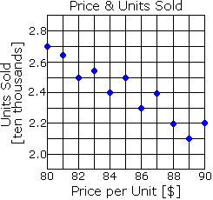  Estimate a line of best fit. On average, what is the price per unit for eighty-six thousand units? | In a triangle, one angle is 40 more than the smallest angle and the 3rd angle is twice the sum of the other two angles. What is the largest angle of the triangle? | Problem 2
Questions adapted from Score21 and SchoolNet

