 | Problem 1 | Problem 2 | Gridded Response
Monday | 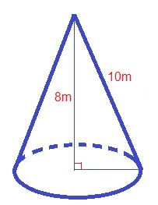  What would the measurement of the radius be for the cone if the volume is 38m³? Round to the nearest whole number. | 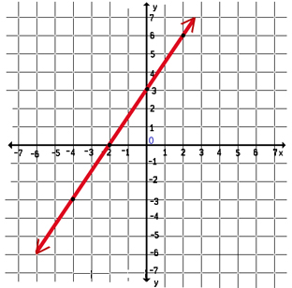  What is the x-value of the  x-intercept of the linear equation below? | Problem 2  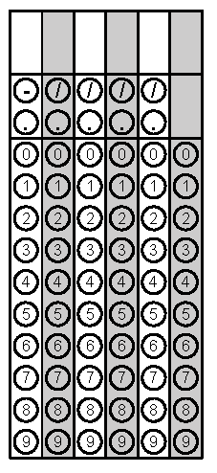
Tuesday | The mouse population in Cary is around 25,000 but is decreasing in size at a rate of 20% per year. What will the mouse population be after 3 years? | 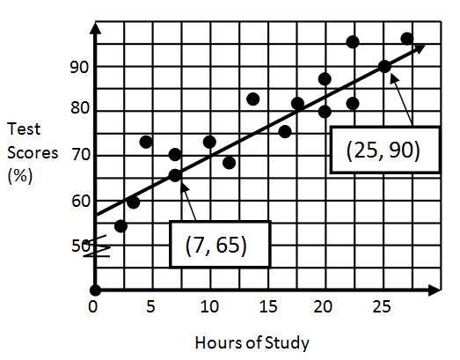  Using the graph of the scatterplot data below, what is the best estimate for the equation of line of best fit? | Problem 1
Wednesday | What is the y-coordinate of the  y-intercept of the line that passes through points (-4, -4) and (4, 8)? | Simplify.  $$\frac{{(3x^{-2}y^{4})}^{-3}}{{(2x^{-5}y^{2})}^{-3}}$$ | Problem 1
Thursday | Is the graph below an example of a function? If no, highlight the area that helped you answer yes or no. Explain either way.  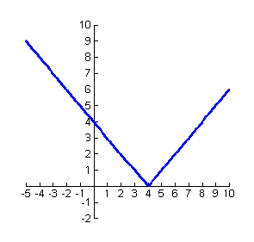 | The cost to rent a construction crane is $750 per day plus $250 per hour of use. What is the maximum number of hours the crane can be used each day if the rental cost is not to exceed $2500 per day? | Problem 2
Friday | Is the graph below an example of a function? If no, highlight the area that helped you determine your answer. Explain.  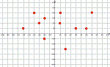 | Isabella wants to get a 91 average for this quarter in science. If she has earned grades of 93, 86, 88, and 98 on her tests this quarter, what grade will she need to score on the last test in order to get a 91 average? | Problem 2
Questions adapted from Score21 and SchoolNet

