 | Problem 1 | Problem 2 | Gridded Response
Monday | Triangle XYZ contains the points X (-3, 7), Y (6, 9), Z (3, 7). What will the coordinates of Z’ after a dilation with a scale factor of 4? | 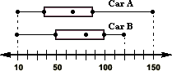  The number of Car A and Car B sold in July by 15 different car dealerships is graphed below. What is the difference between the median sales of the 2 different cars?  Cars Sold in July 2014 | Problem 2  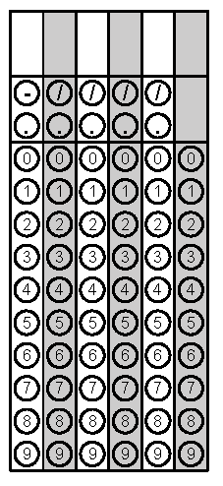
Tuesday | The dishwasher at Meg’s Muffins is loaded with the same number of dishes every time. The table shows the total number of dishes washed as a function of the number of times the dishwasher is used. Based on the data, how many total dishes will be washed by the 9th time?  Times Used Total Washed  2 52  4 104  6 156  8 208 | Compare the growths of Graph A and Graph B.  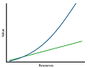  Graph A  Graph B | Problem 1
Wednesday | Suppose there are 50,000 deer in a forest and the growth factor for the population is 1.2 per year. Write an equation you could use to find the deer population p in n years and use it to determine the population of deer in 5 years. | 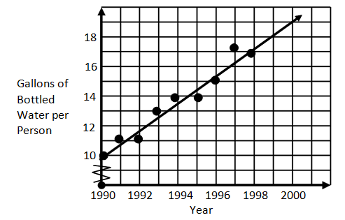  According to the graph below, how many gallons of bottled water will a person need in the year 2000? | Problem 1
Thursday | A triangle is formed with the sides 20 inches, 21 inches, and 29 inches. Is this triangle a right triangle? Prove yes or no. | Mark’s grandma gave him a check for $5000 when he was 5 years old and starting kindergarten. His mom put it in a savings account earning 3% interest compounded semi-annually until he turned 18 and was off to college. If she never put any more money in the account, how much did Mark have to help pay for college? | Problem 2
Friday | 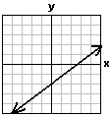  Of the two graphs below, which one represents a direct variation situation? Explain.  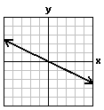 | The length of a rectangle is three times the width. If the perimeter of the rectangles is 48 cm, what is the area of the rectangle? | Problem 2
Questions adapted from Score21 and SchoolNet

