 | Problem 1 | Problem 2 | Gridded Response
Monday | Given the initial term and either common difference or common ratio, write the first 6 terms of the sequence.  a₁ = 7, r = 2 | What is the slope of the graph represented by the equation below? Write your answer as a fraction in lowest terms if necessary.  3x = 12 – 2y | Problem 2  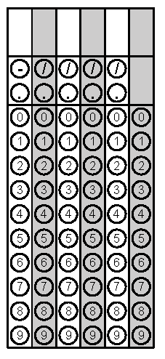
Tuesday | What is the slope of the line represented by the linear equation below? Write your answer as a fraction in lowest terms if necessary.  $\frac{1}{8}$ x + 3y = 3 | Determine if the sequence below is arithmetic or geometric. Then determine the common difference or the common ratio.  2, 6, 18, 54, 162, ... | Problem 1
Wednesday | Three sisters have ages that are consecutive odd integers. The sum of the youngest and 3 times the age of the oldest is 5 less than 5 times the middle sister’s age. How old is the oldest sister? | An airplane descends at a rate of 300 feet for every 5000 horizontal feet that the plane travels. What is the slope of the path of the plane’s descent? Write your answer as a fraction in lowest terms if necessary. | Problem 1
Thursday | The number of chirps a cricket makes in a minute is a function of the temperature. The table below shows the number of chirps and the corresponding temperature. Assuming a linear relationship, find an equation relating the temperature to the number of chirps.  number of chirps 40 60 100 140  temperature (degrees Fahrenheit) 50 55 65 75 | Use the equation to predict the number of chirps a cricket will make when the temperature outside is 60 degrees Fahrenheit. | Problem 2
Friday | Alicia is selling homemade jars of jelly as a fundraiser. She spent $50 on supplies for making the jelly. She plans on selling the jars for $7.50 each. Write a function that models her jelly profits (p) based on the number of jars she sells (j). | What is the minimum number of jars of jelly that Alicia must sell in order for her to make a profit of $2500? | Problem 2
Questions adapted from Score21 and SchoolNet

