 | Problem 1 | Problem 2 | Gridded Response
Monday | In construction, floor space must be planned. If the vertical distance between the first and second floors is 3.6 meters, and a contractor is using the standard step pattern of 28 cm wide for 18 cm high, then how many steps are needed for the staircase? | 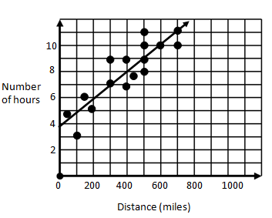  Trudi’s drive to visit her sister is 400 miles away from her house. What is the best estimate of how long her drive will take? | Problem 2  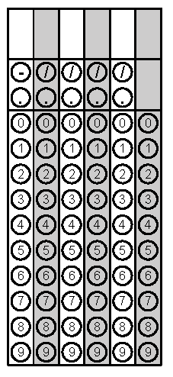
Tuesday | Determine the 6th term in the sequence below:  1, 3, 9, 27........ | Jared collected data on the ages and heights of the kids in his little brother’s elementary school class. He plots all the data on a scatterplot. What type of relationship should he expect to see? | Problem 1
Wednesday | Before the rain began, the water level in Shelley Lake was 268 in. deep. After four hours of rain the lake was 274 in. deep. If the rain continued at the same rate for one more hour, what was the rate of change of inches per hour in the depth of Shelley Lake? Round to the nearest tenth if necessary. | Create a rule for the input-output table below:  Input Output  -3 -10  -2 -7  -1 -4  0 -1 | Problem 1
Thursday | Daryll has an after school job at the sporting goods store. He makes $16.50 an hour and never works more than 20 hours in a week. The equation p(h) = 16.50h models Daryll’s weekly pay p when he works h hours. Describe the possible domain and range for Daryll’s weekly pay. | The perimeter of a rectangle is 42 centimeters. The length of the rectangle can be represented by (x+4) and its width can be represented by (2x-7). What is the area of this rectangle? | Problem 2
Friday | Simply the following expression:  $${\left(3x^{-4}\right)}^{2}(5x^{-2})$$ | The number of calories needed in a daily diet varies directly as to the weight of an individual. If 1,550 calories should be consumed by a 155 lb. person, what is the weight of an individual who consumes 1790 calories a day? | Problem 2
Questions adapted from Score21 and SchoolNet

