 | Problem 1 | Problem 2 | Gridded Response
Monday | What is the domain and range of the line segment on the coordinate plane below?  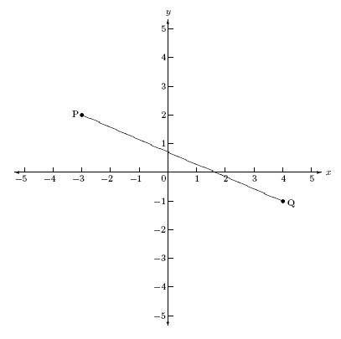 | Lucy’s grade for her CC1 class will be the average of her Unit 1 and 2 tests and her Unit 3 project. If she got a 91 on Unit 1 and an 88 on her unit 2 test, what must she score on her project to earn a 90 average? | Problem 2  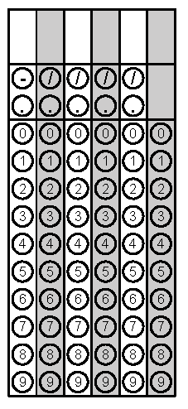
Tuesday | The pressure of a gas varies directly as the temperature of the gas increases. If the pressure is 12.5ATM at a temperature of 250K, what is the pressure at a temperature of 350K? | Using the ordered pairs in the box below, write an equation to represent the relation.  (-1, 8), (-4, -4), (-2, 4) | Problem 1
Wednesday | An airplane is 40,000 ft. above the ground when it begins descending at a rate of 1700 ft. per minute. Assuming the plane continues at the same rate of descent, what is the elevation of the plane after 15 minutes? | 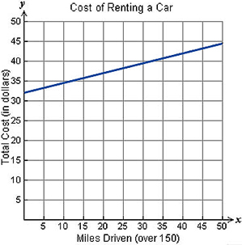  What does the y-intercept of the graph represent? | Problem 1
Thursday | A family will travel 180 miles from their house in Raleigh in order to reach Myrtle Beach. Write an inequality that can be used to find all possible values of t, the time it will take this family to reach the beach in hours, if they travel at an average speed of at least r miles per hour? | The softball coach, Ms. Argese, graphs some data comparing the times at bat vs. the number of hits for her players. She finds the line of best fit to be  y = 0.35x – 22.34 when x is the number of times at bat and y is the number of hits. How many hits should she expect from a player who comes up to bat 110 times? Round answer to nearest whole number if necessary. | Problem 2
Friday | Find three consecutive odd integers such that the sum of the 2nd and 3rd integer is 4 times the 1st. | What is the value of f(-6) when $f\left(x\right)= \frac{13(x-26)}{2}$ ? | Problem 2
Questions adapted from Score21 and SchoolNet

