 | Problem 1 | Problem 2 | Gridded Response
Monday | MillyCakes Bakery has a booth at the Bond Park Arts Festival to sell cupcakes. The booth costs $50 to rent and they sell cupcakes for $3.50 each. Write an equation to represent the profit (p) for the cupcakes(c) they sell.  *Use equation in Problem #2 | If MillyCakes sells 400 cupcakes at the Bond Park Festival, how much profit will MillyCakes make that day? | Problem 2  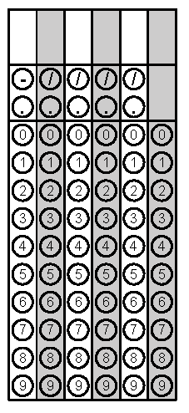
Tuesday | If a line has a slope of $\frac{2}{5}$ and contains the point (5, -7), what is the value of y in the ordered pair  (-5, y)? | Between which two points on the graph was Jaden moving at the fastest rate? Justify your answer.  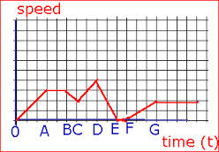  Jaden’s Skateboarding Adventure | Problem 1
Wednesday | Evaluate the expression $2^{3x}$ when x = -2. | 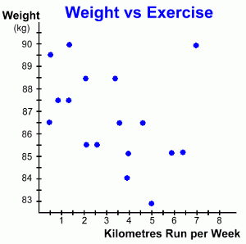  Describe the relationship in detail between the two variables as shown in the scatterplot. Estimate a line of best fit. | Problem 1
Thursday | A bag of M&M’s contains about 150 candies which Ajay eats at a rate of 7 candies every 5 minutes. Write a Now-Next equation to model the number of M&M’s left. Create a chart that would display the first 20 minutes. | Alvin joined a lawn bowling club 2 years ago. He pays an annual membership fee of $875 and a grass fee of $25 each time he plays a game. His total yearly fee is modeled by the function f(g) = 875 + 25g where g represents the number of lawn bowling games he plays. If Alvin paid $1925 this year in fees, how many games did he play? | Problem 2
Friday | The formula A = P + Prt can be used to help you determine how money in your savings account can grow over time. Solve this equation in terms of rate of interest or r. | The amount of money raised at a charity fundraiser is directly proportional to the number of attendees. The amount of money raised for 5 attendees was $100. How much money is raised for 300 attendees? | Problem 2
Questions adapted from Score21 and SchoolNet

