 | Problem 1 | Problem 2 | Gridded Response
Monday | A computer is purchased for $1,400 and depreciates at $160 per year. Write a linear equation to represent the value of the computer after x years. | Michael started a savings account with $300. After 4 weeks, he had $350 dollars, and after 9 weeks, he had  $400. What is the rate of change of money in his savings account per week? | Problem 2  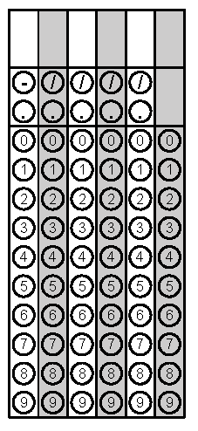
Tuesday | The graph of f(x) = 2^{x} is displayed. What is the value of f(3)?  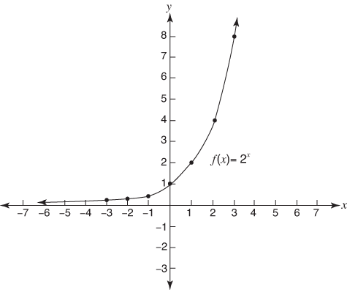 | What value(s) of w make(s) the equation shown below true?  $$w^{2}= \frac{1}{36}$$ | Problem 1
Wednesday | 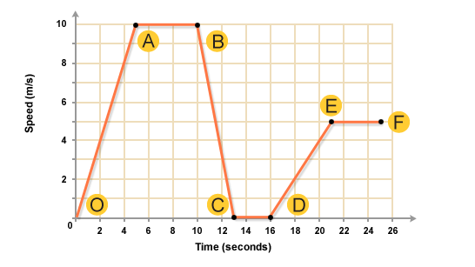  What is the rate of change from point B to point c? Write your answer as an improper fraction if necessary. | The volume of a sphere is 3,600 cm³. What is the approximate diameter of the sphere? ( V = $\frac{4}{3}π$r³) | Problem 1
Thursday | Morris Park is square shaped with an area of 2500 square miles. The park service wants to put boundary fence up around the entire park. How many feet of fencing needs to be purchased to complete the project? | Evaluate h(x) = $\frac{3}{4}$x² – 2 for  h(-12). Write your answer as an improper fraction if necessary. | Problem 2
Friday | Your distance from lightning varies directly with the time it takes you to hear thunder. If you hear thunder 10 seconds after you see the lightning, you are about 2 miles from the lightning.  Write a direct variation equation for the relationship between time and distance. | Using the information from problem #1 - How many seconds would it take for the thunder to travel a distance of 4 miles? | Problem 2
Questions adapted from Score21 and SchoolNet

