 | Problem 1 | Problem 2 | Gridded Response
Monday | Simplify.  $$\frac{24x^{-3}y^{5}z^{2}}{62x^{4}y^{3}z^{-5}}$$ | Evaluate for g(-7).  $$g\left(x\right)= \left|5x-9\right|$$ | Problem 2  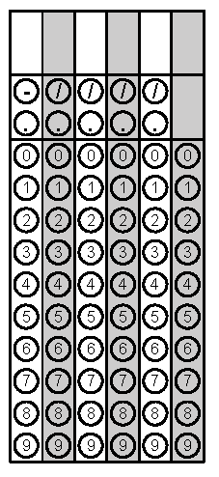
Tuesday | Given: f(x) = 5x – 7  As x increases by 3, f(x) increases by what amount? | Which function below has the steeper slope?  Function #1  x -5 -7 -9 -11  y -10 -16 -22 -28  Function #2  $$y=\frac{1}{3}x-7$$ | Problem 1
Wednesday | 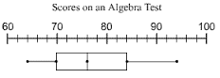  Ms. Adams displayed her student’s scores on the plot below. If Ms. Adams teaches 120 students, how many of her students scored in the top 25%? | When the dependent variable increases when the independent variable increases, the rate of change is ____________.  When the dependent variable stays the same as the independent variable increases, the rate of change is ____________. | Problem 1
Thursday | The Lateral Area for a Cylinder is found by the formula found in the box below. Rewrite the equation to solve for the radius.  L = 2πrh | The cost of an ice cream cone at Dairy Land with toppings is displayed in the table.  # of Toppings Cost  1 $3.75  2 $5.00  3 $6.25  4 $7.50  5 $8.75  What is the price of an ice cream cone with no toppings? | Problem 2
Friday | A famous fast food burger restaurant has increased the basic burger price over the last 60 years. What is the average rate of change per year from 1950 to 2010? Round the price to the nearest cent if necessary.  Year Basic Burger Price  1950 $0.15  1960 $1.75  1970 $3.35  1980 $4.95  1990 $6.55  2000 $8.15  2010 $9.75 | How would you describe the shape of the dot plot below? Explain your reasoning.  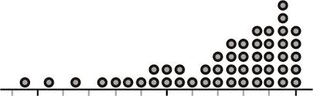 | Problem 2
Questions adapted from Score21 and SchoolNet

