 | Problem 1 | Problem 2 | Gridded Response
Monday | Is the relation below a function? Explain.  {(1,-3), (3, -7), (1, -5), (-5, 7)} | Hinton Cab Company charges $2.50 flat rate pick up charge in addition to $0.45 a mile. Evan has no more than $15 to spend on a ride. How many miles can Evan travel without spending all of his money? Round to the nearest tenth if necessary. | Problem 2  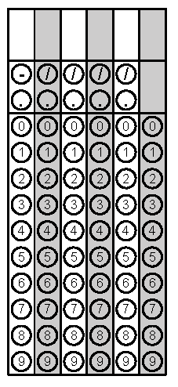
Tuesday | Abbas is selling customizable hats to make money for his winter ski trip. He needs to make at least $500 to go on the trip. After an investment of $700 for hats and materials, how many hats must he sell at $8 each in order to earn enough for his trip? | Micky the dog eats 3 treats a day. The bag originally held 200 treats. Write a NOW-NEXT equation for this scenario. | Problem 1
Wednesday | The sum of the larger and twice the smaller of two consecutive even integers is 62. What is the product of these two numbers? | The area of a trapezoid formula is in the box below. Rearrange the formula to find the length of b₂.  $$A=\frac{1}{2}h(b_{1}+b_{2})$$ | Problem 1
Thursday | 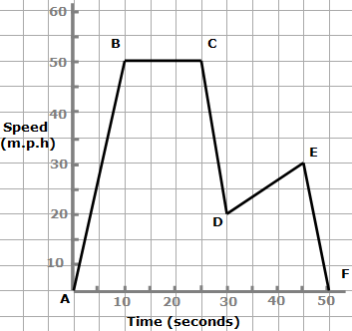  What does the line between point B and point C on the graph below indicate about rate of travel? | A function, f(x), is graphed on the coordinate grid. What is f(-3)?  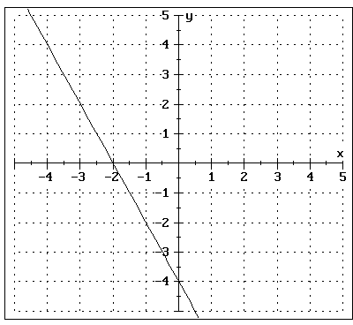 | Problem 2
Friday | The table below shows the relationship between the  number of dozen cookies  sold (c) at Wilson’s Bakery  and the profit (P) earned.  c 1 2 3 4 5  P $5 $10 $15 $20 $25  Write a NOW-NEXT equation to represent this relationship. | Using the Wilson’s Bakery chart from Problem 1, how much profit would be earned if they sold 9.5 dozen cookies? | Problem 2
Questions adapted from Score21 and SchoolNet

