|  |  |  |  |
| --- | --- | --- | --- |
|  | **Problem 1** | Problem 2 | Gridded Response |
| **Monday** | Jamal is a videographer for parties. He earns a monthly salary plus an extra fee for each party. His total monthly income can be expressed by the equation m= 100p + 2000. Jamal decides to double his party fee. Write a new equation to calculate his new monthly income. | A scuba diver is 40 feet below the surface of the water 10 seconds after he entered the water and 100 feet below the surface after 40 seconds. What is the scuba divers rate of change? Write your answer as an improper fraction is necessary. | ***Problem 2***  Grade 6 Math Grid.png |
| **Tuesday** | Mike wants to cover his triangular backyard with grass. If he knows the perimeter of his backyard is 198 yards, how many square yards of grass will Mike need?  x + 6  x  x - 3 | Holland’s Pizzeria Menu   |  |  | | --- | --- | | Toppings (t) | Cost (c) | | 1 | $9.00 | | 2 | $10.50 | | 3 | $13.00 | | 4 | $14.50 |   Write a NOW-NEXT statement representing the cost of a Holland Pizza. | ***Problem 1***  Grade 6 Math Grid.png |
| **Wednesday** | The 8th grade class at Olive MS is planning a picnic celebration at a waterpark. The cost to rent the park is $2250. The cost for each 8th grader is $5.00 and each guest $7.00. Three hundred 8th graders plan on attending the picnic. What is the minimum number of guests that must attend in order for OMS to pay for the park? | Holland’s Pizzeria Menu   |  |  | | --- | --- | | Toppings (t) | Cost (c) | | 1 | $9.00 | | 2 | $10.50 | | 3 | $13.00 | | 4 | $14.50 |   Write a function that represents the cost (c) a pizza with (t) toppings. | ***Problem 1***  Grade 6 Math Grid.png |
| **Thursday** | What is the approximate perimeter of a triangle with vertices of (4, 2), (-3, 5), and (-3, - 4)? | https://www.learningpod.com/apiproxy/content/df200aae-e596-495e-818b-7684ba8e51c3If there are 36 students in Ms. Paytes class #2, how many in the class scored 70% or higher? | ***Problem 2*** |
| **Friday** | Determine the function represented in the table below:   |  |  | | --- | --- | | **x** | **f(x)** | | -1 | -4.5 | | 0 | -1.5 | | 1 | 1.5 | | William paid eight times as much for a dictionary as for a math book. If the difference in price was $6.30, how much did he pay the dictionary? | ***Problem 2*** |

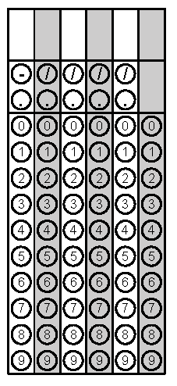 *Questions adapted from Score21 and SchoolNet*