 | Problem 1 | Problem 2 | Gridded Response
Monday | Write a NOW-NEXT statement for the following pattern and determine the 8th term in the pattern.  4, 10, 16, 22, 28 ….. | Simplify the following expression with the following values: x = 4 and  y = -2  $$\frac{x^{2}}{2}+xy^{3}$$ | Problem 2  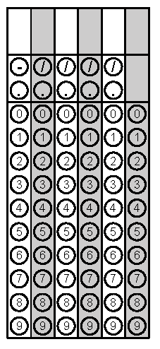
Tuesday | Find the smallest of three consecutive even integers such that the sum of twice the first and three times the third is fourteen more than four times the second. | Write the expression in exponential form.  $$\sqrt[3]{27a^{6}b^{2}c^{3}}$$ | Problem 1
Wednesday | f(x) = x² – 2x + 2; Find f(-3) | To calculate the distance an object travels in a free fall we use the formula  D = ½ gt² where t is time and g is the force of gravity on the object. Solve this equation for t. | Problem 1
Thursday | Simplify.  $${(2x^{\frac{1}{4}})}^{-4}$$ | In $∆$ABC, AB $≅$ AC. If the perimeter of the figure is 111 inches, determine the value of x.  A  B  C  x  6x - 3 | Problem 2
Friday | The sequence below shows the number of pennies Charlotte has collected over the past 5 weeks:  4, 12, 36, 108, 324  Write a NOW-NEXT statement that would help calculate how many pennies Charlotte will collect next week. | The length of the diagonal of a picture frame is 30 cm. If the height of the frame is 18cm, what is the area of the frame? Round to the nearest tenth if necessary. | Problem 2
Questions adapted from Score21 and SchoolNet

