 | Problem 1 | Problem 2 | Gridded Response
Monday | 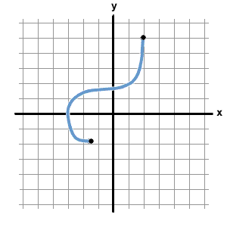  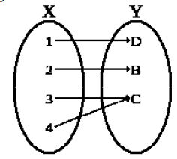  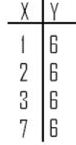  Circle the model(s) that represent a function. Explain. | Find the product of 2 consecutive odd integers where 3 times the 1st is 5 more than twice the 2nd. | Problem 2  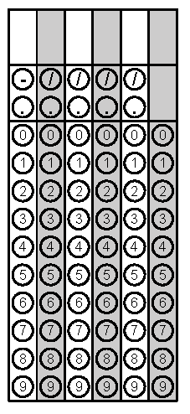
Tuesday | The length of a garden is 4 m more than 3 times its width. If the perimeter of the garden is 56m, what is the area of the garden? | 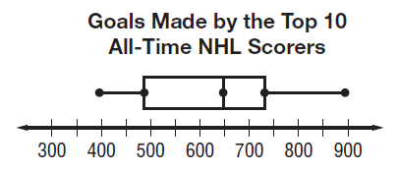  What is the median number of goals made by the top 10 all-time NHL scorers? | Problem 1
Wednesday | INEX Computer Repair charges $55 for materials and $50 an hour to fix and install new software on computers. How much will a 3-hour installation cost? | The formula for potential energy is P = mgh where P is potential energy, m is mass, g is gravity and h is height. Rewrite the formula in terms of gravity. | Problem 1
Thursday | A full 355 mL can of soda is leaking at a rate of 5 mL per minute into an empty can. How long will it take for the two cans to have the same amount of soda? | You are having a catered party for your dad’s big birthday celebration. You can spend at most $1200. The set-up fee is $250 plus $15 per guest. Find the number of people that can be invited and still stay within budget. | Problem 2
Friday | The formula for converting a Celsius temperature to Fahrenheit is $C= \frac{5}{9}\left(F-32\right).$  Convert 56ºC to Fº. Round your answer to the nearest degree if necessary. | A car rental agency advertised renting a Ford Escalade for $24.95 per day and $0.29 per mile. If you rent the car for 2 days, how many whole miles can you drive on a $150 budget? | Problem 2
Questions adapted from Score21 and SchoolNet

