 | Problem 1 | Problem 2 | Gridded Response
Monday | 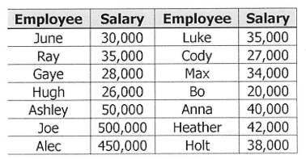  Max listed all the salaries of the Hinton Computer Company employees. What is the most appropriate measure of center to represent the salaries of the computer company? | 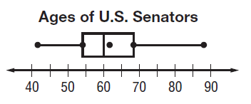  What percent of U.S. Senators are age 60 or older? | Problem 2  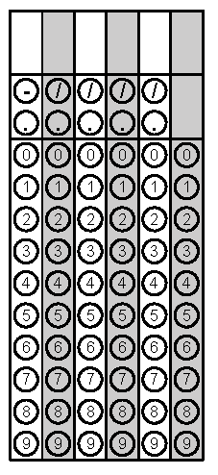
Tuesday | Jinwoo is digging a hole for a swimming pool in the shape of rectangular prism measuring 38 ft. long, 22 ft. wide, and 8 ft. deep. How much water will the pool hold assuming that 1 cubic foot = 7.5 gallons? | Simplify.  $$\frac{{(xy^{2})}^{2}}{x^{3}y^{-1}}$$ | Problem 1
Wednesday | A cube has a volume of 1331 cubic inches. What is the approximate length of each side of the cube? | An isosceles right triangle has a leg that measures 6 in long. About how long is the hypotenuse? | Problem 1
Thursday | UPS charges $7 for the first pound and $0.20 for each additional pound. FedEx charges $5 for the first pound and $0.30 for each additional pound. How many pounds will it take for UPS and FedEx to cost the same? | What is the approximate length, to the nearest tenth, of the diagonal of a square if the perimeter of the square is 53 feet? | Problem 2
Friday | In certain situations, the volume of gas can be found using the equation shown in the box. Rewrite the equation in terms of T.  $$V= \frac{KT}{P}$$ | Rewrite the following expression in exponential form.  $$({\sqrt[4]{2})}^{5}$$ | Problem 2
Questions adapted from Score21 and SchoolNet

