 | Problem 1 | Problem 2 | Gridded Response
Monday | Micah recorded scores on his math quizzes: 84, 85, 91, 81, 45, 92, 99, 91. Which measure of central tendency best represents Micah’s ability in math? Explain. | Liam and Krystal are playing games at the arcade. Liam started with $12 and his machine is $0.50 a game. Krystal started with $18 and her game was $0.75 each turn. How many games will Liam and Krystal have played if they have the same amount of money left? | Problem 2  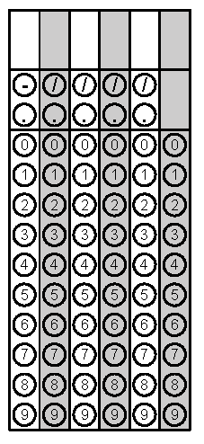
Tuesday | Tony makes a special oil that is used to help heal dry skin. The oil is worth $7 per cubic inch. He sells it in a cone-shaped container with a height of 6 in. and a radius of 2 in. If Tony sells 20 cones of oil, how much money, to the nearest dollar, will he collect? | Ashana purchased a used car and borrowed the money from her mother. Her first four payments left her with balances of $1925, $1750, $1575, and $1400. If this payment schedule continues, how much will she still owe her mom after 9 payments? | Problem 1
Wednesday | 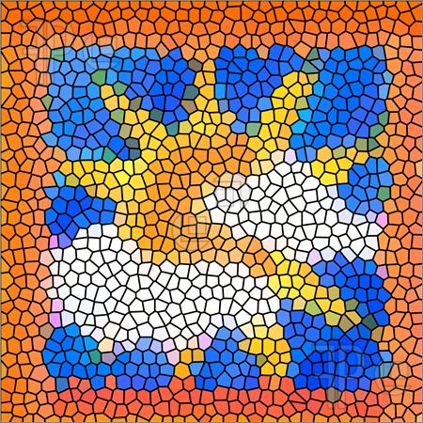  Mr. Canelas created a mosaic tile in the shape of a square to use as a centerpiece on his kitchen wall. To the nearest tenth of an inch, what is the length of the diagonal of the tile?  2 ft. | 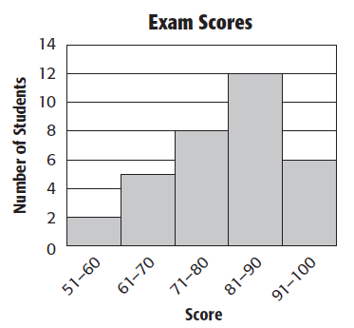  Describe the histogram below using all four distribution descriptors. | Problem 1
Thursday | Simplify the following expression to all positive exponents:  (4x⁴y⁻³)³ | You have just been given a new job in sales. You have two salary options. You can receive a straight salary of $500 per week or you can receive a salary of $200 per week plus 5% of your weekly sales. To the nearest dollar, how much product must you sell each week in order for the commission option to be the better deal? | Problem 2
Friday | Write the following expression in radical form:  (9x²)^{1/2} | Maria had 4 different pieces of wood that are labeled with their lengths. She needs to order them from longest to shortest. What is the correct order of the wood boards if the labels read: 1/3 ft., 0.25 ft., $\sqrt{8}$ft., and 2 ft.? | Problem 2
Questions adapted from Score21 and SchoolNet

