 | Problem 1 | Problem 2 | Gridded Response
Monday | Given the pre-image points D(3, 1), E(-3, 2), and  F(-2, -2); what are the image coordinates after a translation of  (x, y) -> (x -5, y + 2), then a rotation of 90° counter-clockwise. | Happy Mornings Hotel charges its guests $1 plus $0.75 per minute for long distance calls. Good Nights Inn charges $2 plus $0.50 per minute. How many minutes would a guest have to use for the two inns to charge the same amount? | Problem 2  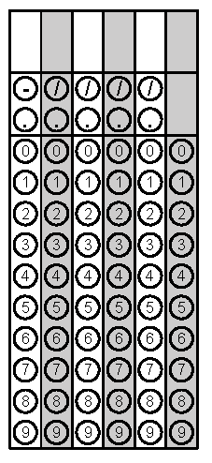
Tuesday | Isaiah delivers cupcakes for MillyCakes. Each cupcake is packed in its own special box in the shape of a cube that measures 5 in. on each side. For delivery he packs the cupcake boxes into a larger cube box that measures 2 feet on each side. How many cupcakes can he fit in a larger box? | Simplify to an expression with all positive exponents.  ($\frac{p^{-4}q}{r^{-3}}$)⁻³ | Problem 1
Wednesday | A painter leans a 20 ft. ladder against the side of a house with the base 5 ft. away from the house. How far, to the nearest tenth of an inch, is the top of the ladder from the bottom of the building? | Express the following equation in radical form:  $${(7x)}^{\frac{3}{4}}$$ | Problem 1
Thursday | The perimeter of a triangle is 78cm and each side is one of three consecutive integers. What are the measures of each side? | Heather’s mom loves coffee. If Heather bought a new can of coffee for her mom when she came for a visit and her mom used ¾ of the can, how much coffee is left in the can? Round your answer to the nearest tenth if necessary.  12 cm  20 cm  Mom’s  Coffee | Problem 2
Friday | A utility pole 10 m high is supported by two wires. Each wire is anchored 3 m from the base of the pole. How many meters of wire are needed for 5 poles? | Mark recently launched a new APP. In the past six days, he has recorded the following number of daily downloads: 37, 29, 37, 56, 45, and 38. He is hoping at week’s end to have an average number of 40 downloads per day. To achieve this, how many downloads must he have on the final day of the week? | Problem 2
Questions adapted from Score21 and SchoolNet

