 | Problem 1 | Problem 2 | Gridded Response
Monday | 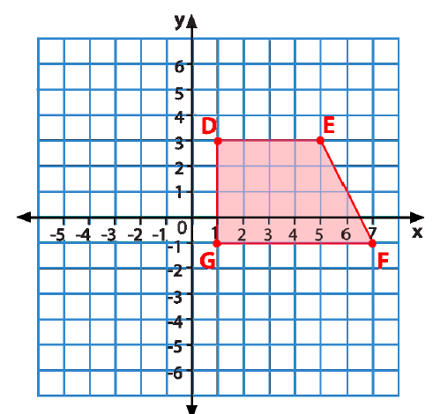  If quadrilateral DEFG is rotated 90º clockwise around the origin, list the new coordinates for each of the vertex points. | DJ is starting a smoothie company. He wants to start out small and only offers strawberry, banana, or peach smoothies with fruit, granola, or nuts added in. How many smoothies can DJ offer? | Problem 2
Tuesday | Once the proposed bridge is built, how many miles will be saved driving from Town A to Town B?  Town A  Proposed Bridge  Town B  9 miles  12 miles | A freight elevator is designed to hold 2600 pounds. A 170 lb. workman has to move 80 lb. boxes to storage. What is the maximum number of boxes he can move on each trip? | Problem 1
Wednesday | At the market, Meyer buys a bunch of bananas for $0.45 per pound and frozen lasagna for $5.99. If Meyer’s total was $9.14, how pounds of bananas were purchased? | Tracy keeps her cat’s food in a can that is 8 inches tall and has a diameter of 6 inches. She keeps her dog’s food in a can 10 inches tall with a diameter of five inches. Which container can hold more food? | Problem 1
Thursday | Simplify the following expression so that there are only positive exponents.  $$\frac{{(z^{3}y^{2})}^{5}}{z^{10}y^{16}}$$ | The measures of the angles of a triangle are 60º, 25º, and 95º. What is the measure of the largest exterior angle of the traingle? | Problem 2
Friday | Phil is Tom's father. Phil is 35 years old. Three years ago, Phil was four times as old as his son was then. How old is Tom now? | By the end of its 1st week a new movie has grossed $4.6 million. By the end of the sixth week it had grossed $13.8 million. If the movie continues to make money at the same rate, how much will it make by the 9th week? | Problem 2
Questions adapted from Score21 and SchoolNet

