 | Problem 1 | Problem 2 | Gridded Response
Monday | 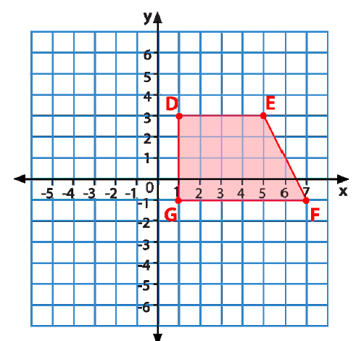  If quadrilateral DEFG is reflected across the x-axis, list the new coordinates for each of the vertex points. | 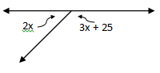  Find the value of x. | Problem 2  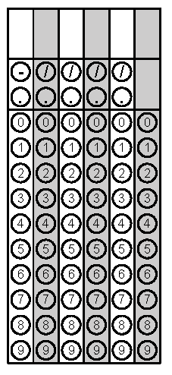
Tuesday | You place a steel ball with a diameter 4 cm in a water-filled cylinder that is 5 cm in diameter and 10 cm high. What volume of water will spill out of the cylinder? | Simplify the following expressions so that there are only positive exponents:  (-4x²y)(-3y³z)  (-2x⁵y⁻⁴)⁻³ | Problem 1
Wednesday | Zain has a piece of paper that measures 6.5 inches by 6.5 inches. If he folds the paper diagonally in half, how long is the folded side? Round your answer to the nearest tenth if necessary. | A fourteen inch candle and a twenty inch candle are lit at 2:00 pm. The 14-in candle burns 0.5 inches every hour. The 20-in candle burns two inches every hour. At what time will the two candles be the same height? | Problem 1
Thursday | The length of a rectangle is twice its width. The perimeter of the rectangle is 90 cm. what is the area of the rectangle? | Pavel wants to fence his square chicken coop that has an area of 625 square feet. How much fencing does Pavel need to purchase? Round your answer to the nearest tenth if necessary. | Problem 2
Friday | A tennis ball is dropped from a height of 60 ft. If the ball bounces ½ as high on each successive bounce, what is the height on the fourth bounce? | 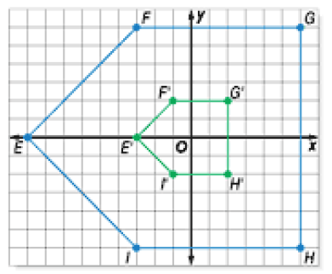  Polygon EFGHI was dilated to E’F’G’H’I’ as shown on the coordinate plane. By what scale factor was the polygon dilated? | Problem 2
Questions adapted from Score21 and SchoolNet

