 | Problem 1 | Problem 2 | Gridded Response
Monday | 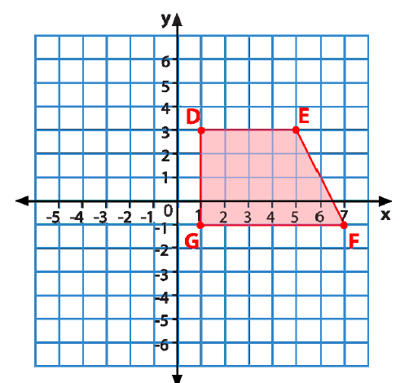  If quadrilateral DEFG is reflected across the y-axis, list the new coordinates for each of the vertex points. | 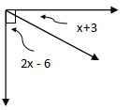  Find the value of x. | Problem 2  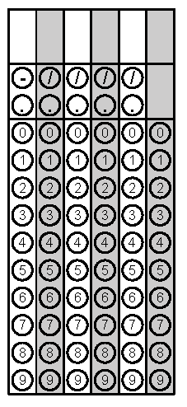
Tuesday | Ms. Milly’s favorite candy comes in a package that looks like a triangular prism. If b = 6 cm, h = 5 cm, and H = 12 cm in the picture of the candy below, what is the volume of the package?  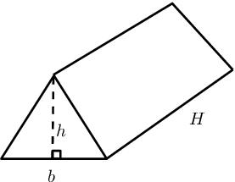 | If a special holiday version of Ms. Milly’s favorite candy came out and it was advertised at 40% larger than the regular version, how much more candy does she get with the new holiday size? (Reference problem #1) | Problem 1
Wednesday | 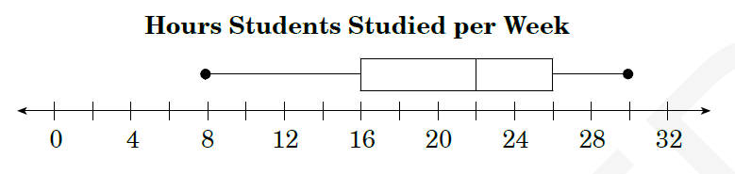  What percent of students study less than sixteen hours per week? | Mrs. Xu is planning her dinners for next week. The choices for dinner are beef, chicken or pork. The choices of vegetables are broccoli, peas, carrots and the choice of carbohydrates are baked potatoes, brown rice, egg noodles, or sweet potatoes. How many possible meals can Mrs. Xu make with all those choices? | Problem 1
Thursday | Find the value of x if line j is parallel to line g.  j  (6x + 60)º  (10x - 20)º  g | Your PE teacher, Mr. Hoey counted his heart beat for eight minutes. He counted a total of 576 beats. If his heart beat was steady throughout the day, how many beats would have occurred after just 2 minutes? | Problem 2
Friday | Mr. Hale bought a new boat for $58,000. He made a down payment of 20% and got a loan from the bank for the remaining amount of the loan. How much did Mr. Hale have to borrow from the bank? | A square tile has an area of 144 cm². What is the perimeter of the tile? | Problem 2
Questions adapted from Score21 and SchoolNet

