 | Problem 1 | Problem 2 | Gridded Response
Monday | 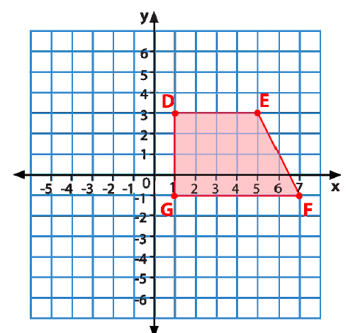  If quadrilateral DEFG is translated by the rule  (x -5, y + 2), list the new coordinates for each of the vertex points. | 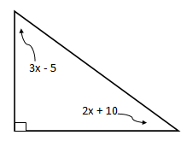  Find the value of x. | Problem 2  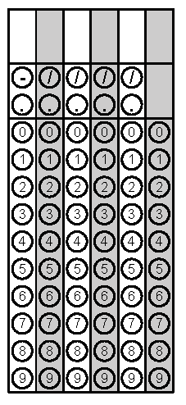
Tuesday | Britt sold half of his action figure collection. He then felt sad and bought 18 more. He now has 128. How many action figures did Britt have in his original collection? | For what value of x satisfies the equation$\frac{- 4x-2}{3}=- 6$? | Problem 1
Wednesday | What is the product of two consecutive integers with a sum of 121? | Terri’s bathtub is the shape of a rectangular prism. The tub has a length of 54 inches, width of 30 inches, and a height of 15 inches. How many cubic inches of water can it hold? | Problem 1
Thursday | If the perimeter of a rectangle is 648m and the base is twice as long as the height, what are the dimensions of the rectangle? | Juan bought a gaming system at a 20% discount. The original price of the system was $389. There was a 7% sales tax. How much did he pay for the system, including tax? Round your answer to the nearest cent. | Problem 2
Friday | Mickey is a personal chef who will come to your house and make dinner for parties. He charges $250 per party plus $75 for every hour he works at your house. How much would Chef Mickey earn if he worked for your family for 6 hours? | Evan bought 5 t-shirts (each shirt was the same price) and a $10 tie. Renee bought two of the same shirts. If together they spent 62.50, what was the cost of each shirt? | Problem 2
Questions adapted from Score21 and SchoolNet

