 | Problem 1 | Problem 2 | Gridded Response
Monday | John earns $15 an hour mowing lawns. Write and solve an equation to find out how many hours he must work to earn $315. | During one possession of a football game, the Panthers gained 15 yards, lost 2 yards, lost 20 yards, gained 3 yards and lost 14 yards. At the end of the possession, how many yards had they gained or lost? | Problem 2  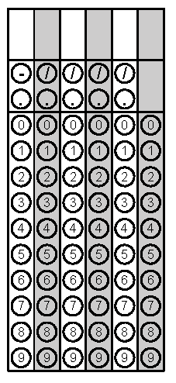
Tuesday | How much sand is needed to fill a hole that is ten meters deep, eight meters wide, and twelve meters long? | Mrs. Kidd took her two children to a waterpark for summer fun. An adult ticket cost $32 and the total price of admission for Mrs. Kidd’s family was $84. How much was a child’s ticket? | Problem 1
Wednesday | The temperature at noon on a winter’s day was 14ºF. At midnight the temperature had dropped 23ºF. What was the temperature at midnight? | An industrial oil drum is pictured below. How many cubic feet of oil can the drum hold when it is completely full? Round your answer to the nearest whole number if necessary.  7.8 feet  4.9 feet | Problem 1
Thursday | Simplify the expression below.  5(-x + 12) – 3(x – 10) | Simplify the expression below when x = -4 and y = 5.  x² + (xy)² | Problem 2
Friday | Nancy needs to cover her yard with grass. The diagram of her backyard is shown below. How many square feet of grass does Nancy need?  103 ft.  House  Yard  45 ft.  22 ft.  58 ft. | Yvette needs to cover her yard with grass. The diagram of her backyard is shown below. How many square feet of grass does Yvette need? Round your answer to the nearest tenth if necessary.  24 ft.  10 ft. | Problem 2
Questions adapted from Score21 and SchoolNet

