Name: _________________________________________ Date: ____________ Period: ______

Review Practice 3 – Math 8th

1. Is the relation a function?

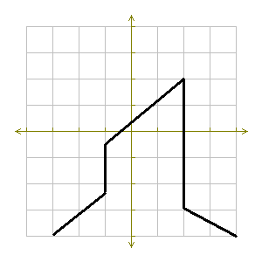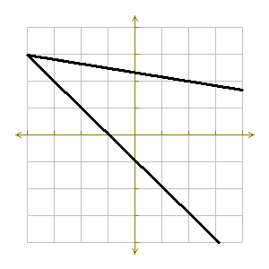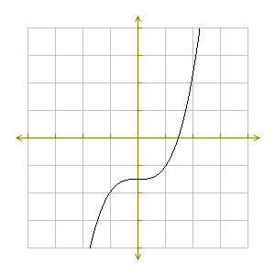 

2. Are the following relations functions?

a. y = 2x + 1

b. {(3, 2) (4, 5) (8, 3) (4, 2)}

 c.

1. State the inputs and outputs for the following ordered pairs.

(-9, 0), (4, 5), (2, -6), (-6, -2), (2, -4)

Inputs:_________________________ Outputs:_______________________

Is this a function and why?

|  |  |  |  |
| --- | --- | --- | --- |
| X |  | Y | (X, Y) |
| -2 |  |  |  |
| -1 |  |  |  |
| 0 |  |  |  |
| 1 |  |  |  |
| 2 |  |  |  |

1. Complete the table of values. Is this a function? Why?

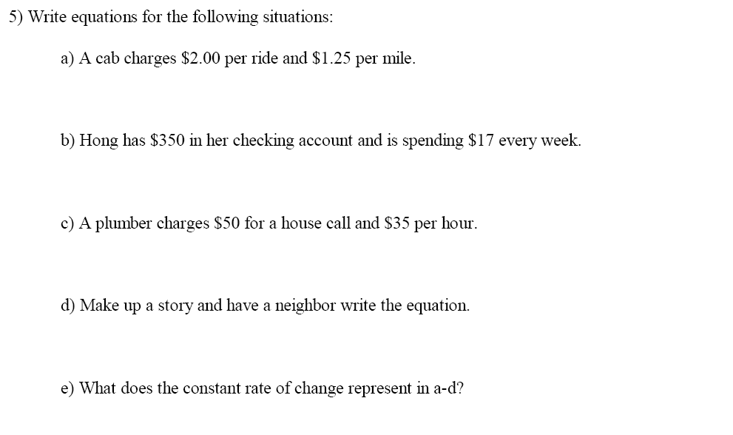

1. What linear equation has the greatest rate of change?
2. y = 3x + 1
3. y = .25x – 6
4. y = 5x2 + 2.5
5. y = -9x3 – 4
6. y = - 6x + 8
7. y = 2x
8. 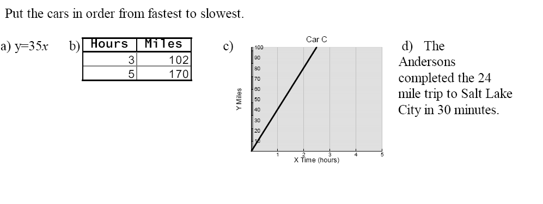The following relations represent the speed of four cars.
9. Evaluate the function f(x) = 3x – 5 for the following domain D: {- 5, - 3, -2, 0, 1, 4, 6}
10. What is the range of function f(x) = 2x2 for the domain D: {-2, -1, 0, 1, 2}?
11. Determine the slope of the lines formed by graphing the ordered pairs below
12. (1, 2), (3, 6)
13. (2, 6), (4, 0)
14. (8, −4), (−6, −4)
15. (7, 1), (7. 8)
16. (-2, 1) (3, 4)

|  |  |  |  |  |  |  |  |  |  |  |  |  |  |  |  |  |  |  |  |  |  |  |  |  |  |  |
| --- | --- | --- | --- | --- | --- | --- | --- | --- | --- | --- | --- | --- | --- | --- | --- | --- | --- | --- | --- | --- | --- | --- | --- | --- | --- | --- |
| |  |  | | --- | --- | | **x** | **y** | | 1 | 3 | | 2 | 6 | | 3 | 9 |   linear nonlinear | |  |  | | --- | --- | | **x** | **y** | | 1 | 1 | | 2 | 4 | | 3 | 9 |   linear nonlinear | |  |  | | --- | --- | | **x** | **y** | | 1 | 2 | | 2 | 5 | | 3 | 10 |   linear nonlinear |

1. Classify the following tables as linear or nonlinear. If linear, find the rate of change.
2. If the graph of a line slants upward from left to right, than the slope of the line is __________________.

If the graph of a line slants downward from left to right, than the slope of the line is __________________.

If the graph of a line is horizontal, than the slope of the line is _________.

If the graph of a line vertical, than the slope of the line is said to be __________________.

1. Find the rate of change and the equation of function represented in the table. Create a story that would go with the relation from the table of values.

|  |  |
| --- | --- |
| Time (days) | Cost ($) |
| 3 | 75 |
| 4 | 100 |
| 5 | 125 |
| 6 | 150 |

1. Find the slope and the y-intercept of the line 3x + 6y = 18
2. Which of the following lines is the steepest?

y = ½ x y = 4x y = x y = 2x

Why?

1. 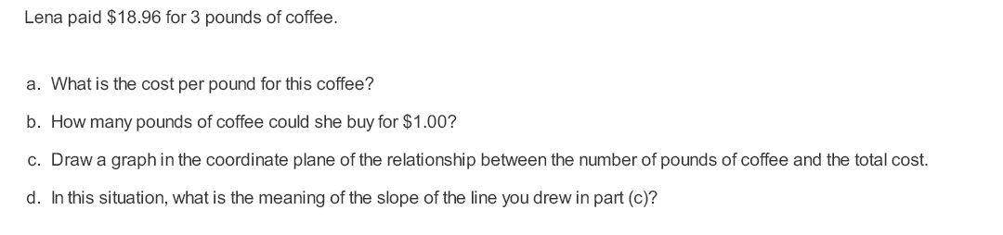
2. Are all equations functions? Explain and give few examples.
3. What the coefficient of a linear equation represents?
4. Put the following linear equations in order from the least steep line to the steepest line.

y = ½ x y = x y = 3x y = $\frac{2}{3}x$ y = ¾x y = 5x

1. How is the graph of y =4x similar and different from the graph of y = ½ x?
2. Solve the systems
3. $y=2x-10$ b.  c. $4x+3y=10$
4. Find the equations of the lines:

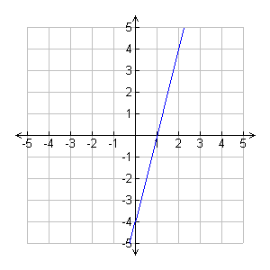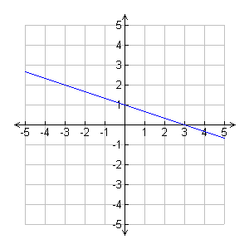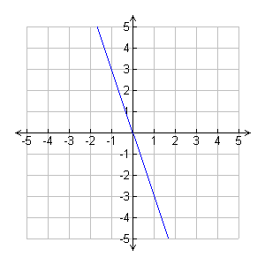

1. Graph the following lines:

y = 1/3 x + 2

y = -4x + 6

y = 3x

y = 2/5 x – 3

1. Find the slope and y-intercept for the following equations

a. y = 5x + 4 b. y = -2x – 3 c. y = -x + 7

Slope ___ slope ___ slope ___

y-intercept ___ y-intercept ___ y-intercept ___

d. y = x – 5 e. y = 2x f. y - 4x = 5

Slope ___ slope ___ slope ___

y-intercept ___ y-intercept ___ y-intercept ___

1. Write an equation in slope intercept of a line with the following.

a. slope -2; y-intercept at (0, -2) b. slope 1; y-intercept at (0,5)

26. What type of correlation is shown in the scatter plot below?



1. The scatter plot below shows the number of students per class at Monida Middle School and the number of magazine subscriptions each class sold for a fund-raiser. 

Draw a line of best fit on the scatter plot. What type of association the data shows? About how many subscriptions did the class of 30 students sell?

1. A scatter plot shows a negative relationship between the two variables. What kind of slope would the line of best fit have?
2. An electrician charges customers a basic rate of $22 for making a service call plus $35 for each hour worked. Write an equation to represent the total charge, C, if h represents the number of hours worked. What is the y-intercept? Explain its meaning.

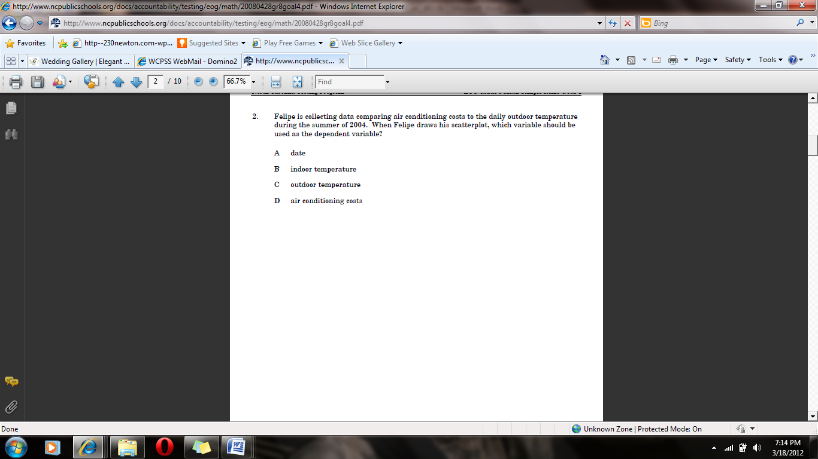

1. 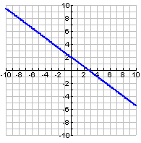Find the equation of the line represented in the graph. Create a table of values for this function and a story that could be represented by this graph.
2. An airplane 30,000 feet above the ground begins descending at the rate of 2000 feet per minute. Assume the plane continues at the same rate of descent. The plane’s height and minutes above the ground are related to each other.

Identify the variables in this situation: x= _________________ y= __________________

What is the given information in this problem (find all that apply)?

y-intercept ________ slope _____ one point  a second point: 

a. Write an equation to model the situation.

1. Use your equation to find the altitude of the plane after 5 minutes.
2. Suppose you receive $100 for a graduation present, and you deposit it in a savings account. Then each week thereafter, you add $5 to the account but no interest is earned. The amount in the account is a function of the number of weeks that have passed.

Find the equation for this story.

Use your equation to find when you will have $310 in the account.

1. Diane knows a phone call to a friend costs 25 cents for the first 3 minutes and 10 cents for each additional minute. The number of minutes you call and the cost of the call are related.

Find the equation she could use to calculate how much a 15 minutes phone call will cost her.

1. Biologists have found that the number of chirps some crickets make per minute is related to temperature. The relationship if very close to being linear. When crickets chirp 124 times a minute, it is about 68 degrees Fahrenheit. When they chirp 172 times a minute, it is about 80 degrees Fahrenheit.

Identify the variables in this situation: x= _________________ y= __________________

What is the given information in this problem (find all that apply)?

y-intercept ________ slope _____ one point  a second point: 

a. Find an equation for the line that models this situation.

b. How warm is it when the crickets are chirping 150 times a minute?

1. The perimeter of a rectangular garden is 62 feet. The length is 1 foot more than twice the width. Find the dimension of the garden.
2. Sally’s $1800 savings is in two accounts. Her total interest for the year was $93 from one account earning 6% interest and another earning 3% interest. How much does she have in each account?
3. An executive traveled 1930 miles by car and plane. He drove to the airport at an average speed of 60 mph and the plane averaged 350 mph. The total trip took 8 hours. How long did it take to get to the airport?
4. A boat traveled 24 miles downstream in 2 hours. The return trip took twice as long. What is the speed of the boat in still water?
5. Two angles are complementary. The larger angle is 3 degrees less than twice the measure of the smaller angle. Find the measure of each angle.