linear relations [2649297]
Student
Class
Date

1. | What value of x satisfies the equation ?

A. | –16

B. | –12

C. | 0

D. | 4

2. | The graph below represents the number of grams of fat versus the total number of grams in a certain type of potato chip.  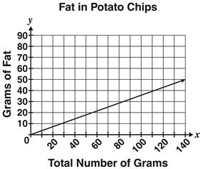  Which equation BEST represents the relationship shown?
 | A.
 | B.
 | C.
 | D.
3. | The graphs below shows a change in the slope of the Line m from to  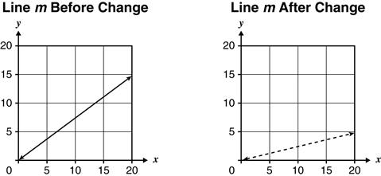  Which statement is true for the value of y when x has a value of 12?
 | A. The value of y increased from 1 to 3.
 | B. The value of y decreased from 3 to 1.
 | C. The value of y increased from 3 to 9.
 | D. The value of y decreased from 9 to 3.

4. | Samuel received a jar with 2 pennies in it today, and he will add 2 more pennies to it each day. The relationship between x, the number of days that pass, and y, the total number of pennies in the jar, is graphed below.  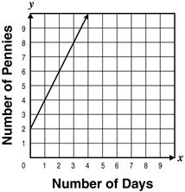  Lisa also has a jar containing 2 pennies. She will add 4 rather than 2 pennies to it each day. Which graph shows the x and y relationship described above with respect to Lisa’s jar?
 | A.
 | B.
 | C.
 | D.

5. | The graph below shows the number of grams of protein in different amounts of peanut butter.  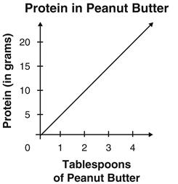  The slope of the line is Which statement BEST describes the meaning of the slope?
 | A. There are 5 grams of protein in 1 tablespoon of peanut butter.
 | B. There are 5 tablespoons of peanut butter in 1 serving.
 | C. There is 1 gram of protein in 5 tablespoons of peanut butter.
 | D. There are 5 tablespoons of peanut butter to 5 grams of protein.

6. | During exercise, the target heart rate y (in beats per minute) can be calculated using the formula , where x is a person’s age.  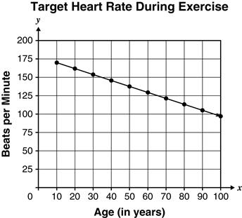  What does the slope of the line represent?
 | A. the change in target number of beats as the number of minutes increases
 | B. the change in number of minutes as the target number of beats increases
 | C. the change in age as the target number of beats per minute increases
 | D. the change in target number of beats per minute as age increases

7. | A tank initially contained 9 liters of water when Emily began to fill the tank with a water hose. The linear relationship between the number of liters of water in the tank and the time in minutes Emily has been filling the tank is represented in the table.  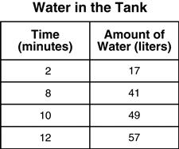  Which description of the slope of this relationship is true?
 | A. The slope is 4 and represents the rate at which the water flows into the tank in minutes per liter.
 | B. The slope is 4 and represents the rate at which the water flows into the tank in liters per minute.
 | C. The slope is and represents the rate at which the water flows into the tank in minutes per liter.
 | D. The slope is and represents the rate at which the water flows into the tank in liters per minute.

8. | Joanna pays $40 plus a $2 surcharge each month for her high-speed internet service. Which table BEST represents the relationship between m, the number of months, and t, the total amount Joanna pays for the service?
 | A.
 | B.
 | C.
 | D.

9. | Which graph represents the movement of a train whose distance from a starting point changes at a constant rate?
 | A.
 | B.
 | C.
 | D.

10. | The graph of the equation is shown.  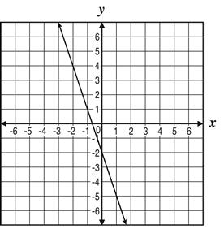  Which table BEST represents the relationship between x and y in the graph?
 | A. x y –2 0 –5 1 1 –1
 | B. x y –2 0 –5 1 –5 –1
 | C. x y 0 –2 1 –5 –1 –5
 | D. x y 0 –2 1 –5 –1 1

