functions features [2649055]
Student
Class
Date

1. | A taxi cab charges an initial fee of $2.50, a rate of $0.65 per mile for the first 20 miles, and then a rate of $0.45 per mile for distances greater than 20 miles. Which of the following equations shows the cost y, in dollars, for a cab ride that is x miles long, if the total distance is greater than 20 miles?
 | A.
 | B.
 | C.
 | D.

2. | The first term of the arithmetic sequence below is equal to 2.  2, 7, 12, 17, 22, 27, . . .  Which term of the sequence is equal to 137?
 | A. 28th
 | B. 27th
 | C. 26th
 | D. 25th

3. | Which function has the largest value for f(–3)?
 | A. f(x) = 2x – 5
 | B. f(x) = 2 – 4x
 | C. f(x) = 6 – 3^{x}
 | D. f(x) = 2^{x} + 10

4. | Emma and Kyle combine their earnings to pay their bills. Emma’s earnings can be modeled by the equation E(x) = 22.75x + 74, where x is the number of hours worked in a week. Kyle’s earnings are modeled by the equation K(x) = 17.85x + 127, where x is the number of hours worked in a week. Which function models their combined earnings, C(x), if they each work the same number of hours in a week?
 | A. C(x) = 241.60x
 | B. C(x) = 40.60x + 201
 | C. C(x) = 40.60x + 53
 | D. C(x) = 4.90x – 53

5. | Which coordinate pair represents the x-intercept of the graph of the equation
 | A.
 | B.
 | C.
 | D.

6. | Which is an equation of the function graphed below?  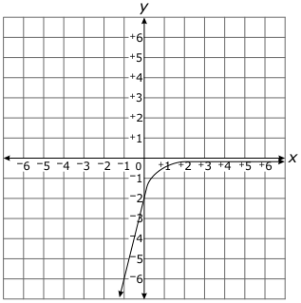
 | A. f(x)=−2(13)x
 | B. f(x)=2(13)x
 | C. f(x)=−13(2)x−2
 | D. f(x)=13(2)x−2

7. | Which graph BEST represents the equation
 | A.
 | B.
 | C.
 | D.

8. | According to package information, frozen vegetables will stay fresh for different amounts of time if stored at different temperatures as shown in the chart below.  Number of Months Temperature (°C)  0.4 5  2 2  12 – 18  Which graph shows the relationship between the number of months and the temperature?
 | A.
 | B.
 | C.
 | D.
9. | The table below shows the weight of a truck in pounds, w, as it increases for each crate of fruit, f, loaded onto it.  Number of Crates of Fruit Loaded on Truck (f) Total Weight of Truck (w)  6 10,680  10 12,200  13 13,340  16 14,480  21 16,380  What is the weight of the truck before any fruit is loaded onto it?
 | A. 1,780 pounds
 | B. 8,400 pounds
 | C. 8,780 pounds
 | D. 10,680 pounds
10. | The following equation is used to predict the cost, c, in dollars, to produce g units of some item.  Which is a reasonable range for the cost to produce less than 100 items?
 | A.
 | B.
 | C.
 | D.

11. | The weight, in pounds, of a baby in the first six months of life can be modeled by the function , where x is the age of the baby in months. According to this model, what is the weight, in pounds, of a baby at age 5 months?
 | A. 8.5
 | B. 12.0
 | C. 13.5
 | D. 14.5

12. | A line segment is drawn in the coordinate plane. What is its domain and range?  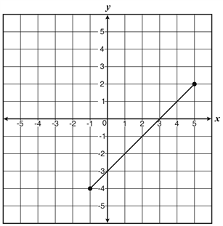
 | A. and
 | B. and
 | C. and
 | D. and
13. | A sequence is defined below.  ,  What is the 6th term of this sequence?
 | A. 9
 | B. 10
 | C. 25
 | D. 29
14. | The cost to rent a van can be modeled by the function, V = 45 + 0.10m, where V is the cost to rent the van and m is the total number of miles the van is driven. What does the y-intercept represent in the context of the problem?
 | A. the total cost to rent the van
 | B. the cost per mile to rent the van
 | C. the total miles the van was driven
 | D. the initial cost to rent the van
15. | In 1980, researchers found there were 100 bears in an area. The researchers determined that each year the bear population increased by 6.2%. What does the 6.2 represent?
 | A. the average number of bears the population increases by each year
 | B. the average number of bears the population decreases by each year
 | C. the growth factor for the bear population
 | D. the decay factor for the bear population

