Multiple Representations and Key Features of Exponential Functions
Name _________________________
Exponential functions ________________ at an ___________________ rate, or _________________ at a ________________________ rate. Their graphs ___________________ .
Explicit exponential equations can be written as _________________, where the variable _________ represents the __________________ and the variable _________________ represents the ______________________.
Recursive exponential equations can be written as _________________________, where the variable _________ represents the __________________ and the variable _________________ represents the _________________________.
If $b>1,$ then there is exponential ___________________. This means that as the independent variable increases, the dependent variable is ___________________ at an ________________ rate.
If $0<b<1$, then there is exponential _________________________. This means that as the independent variable increase, the dependent variable _________________________ at a _______________________ rate.
Example: In August 2011, the population in the United States was approximately 312 million. Suppose that the population grows at a rate of 1.7% of the population each year. Represent this rate of growth with a table, graph, symbols, and words.
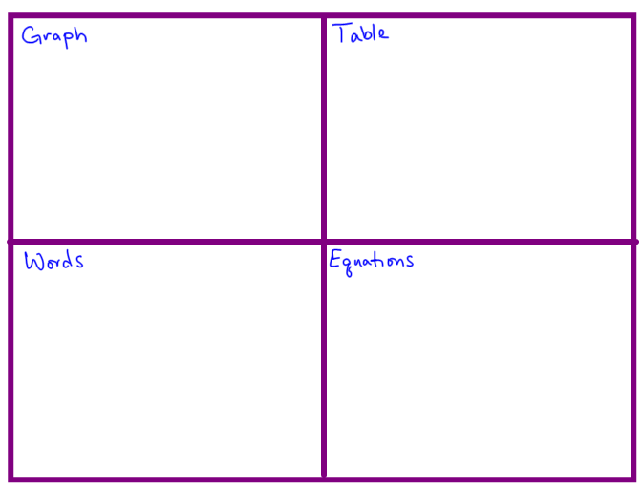
Independent Practice
In science class you are studying bacteria growth. In your petri dish there are 12 bacteria. After one minute each bacterium splits in two creating 24 bacteria. After another minute each bacterium again splits in two creating 48 bacteria. Model the growth of the bacteria by using a table, graph, words, and symbols.

