Name ____________________________

Math 8: The Slope Formula

Directions: Fill in the blanks below as you watch the video.

Let’s Review: Find the Slope
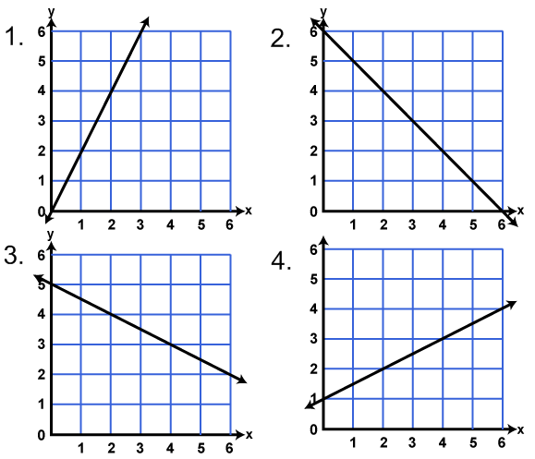

Example 5: Find the slope of the line that passes through
(-3,-4) and (-2, 4) – BY GRAPHING.
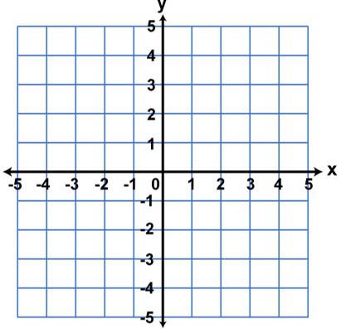

Example 5: Find the slope of the line that passes through
(-3,-4) and (-2, 4) – with the SLOPE FORMULA.
.
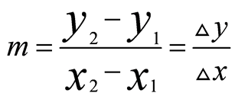

Example 6: Find the slope of the line that passes through
(5,1) and (2, 3) – with the SLOPE FORMULA.

