Name ____________________________

Math 8: Real-Life Slope, Part 1

Directions: Fill in the blanks below as you watch the video.

Tommy’s Texting
Number of texts (x) Cost (y)  2 $16  4 $32  Rise = _____________  Run | 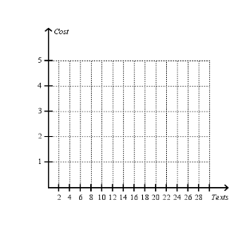
What is the rate that he is charged for texts? $ __________ / ___________

You Try!: Penelope’s Paycheck
Hours (x) Pay (y)  2 $16  3 $24  Rise = ___________  Run | 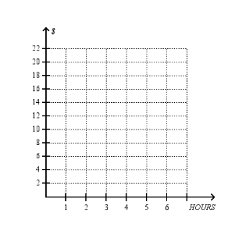
What is her pay rate? $ __________ / ___________

