Name ____________________________

Math 8: Intro to Slope

Directions: Fill in the blanks below as you watch the video.

SLOPE is the rate of change from one point to the next on a line.
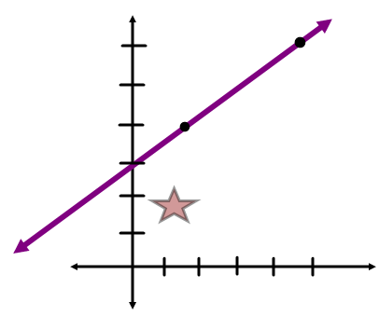 | _______ is the slope of  the line

SLOPE is also called " _________ over ______ ". It is the ratio of the _______ of the line (which is the vertical change) over the ______ of the line (which is the horizontal change.)
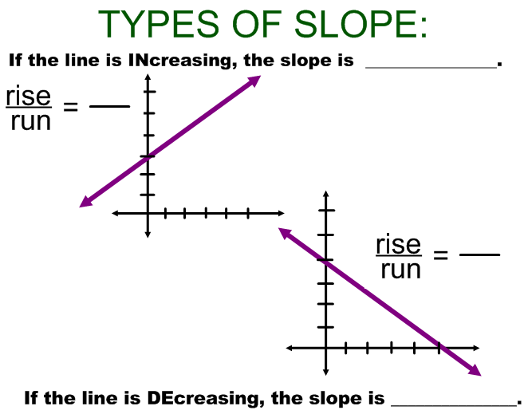
You Try! Draw a line with a positive slope with a dashed line. Draw a line with a negative slope with a solid line.

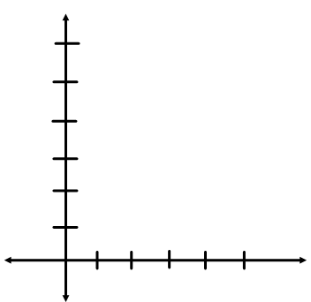

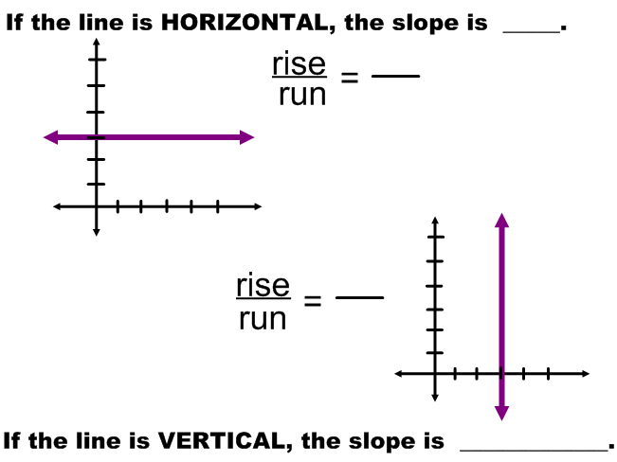

You Try! Draw a line with a undefined slope with a solid line. Draw a line with a zero slope with a dashed line.

