Name ____________________________

Math 8: Writing and Evaluating Functions
Directions: Fill in the blanks below as you watch the video.

How do we write functions?
- function notation is _______________

- read as "f of x"

- Example: _________________

Functions are like __________________!

They have an ________________ and an _______________.

Input = __________ = ___

Range = __________ = _____ = ___

How do we evaluate functions?

- Evaluate means ___________!
- We "solve" functions by substituting (plug in) an ______ (x) value into our function. Our answer is the ________ (f(x)).
- We will always be given a ___________ ______ .A function rule is an ____________ that establishes the relationship between the domain (input or x) and the range (output or y).

Example 1: Evaluate f(x) = x + 5 for x = 1.
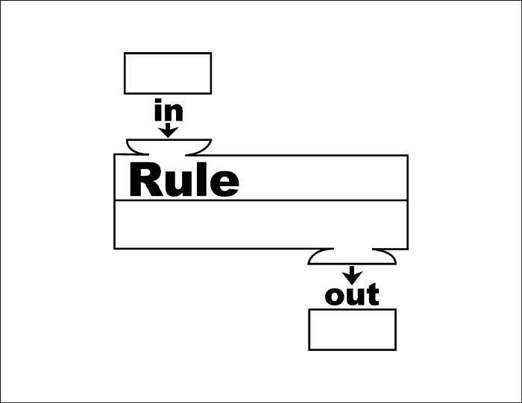

Example 2 – You Try: Evaluate f(x) = x/4 for x = -4.
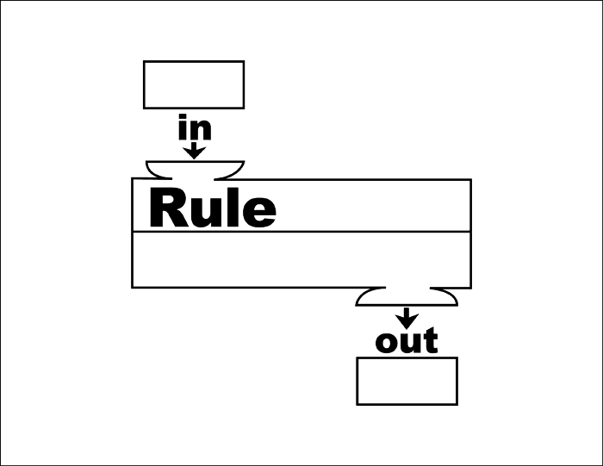

Example 3: Find f(-3) and f(2) for f(x) = -2x - 4.

Example 4 – You Try: Find f(-5) and f(3) for f(x) = 3x - 1.

Example 5: Evaluate f(x) = 3x + 1 for the values given in the table.
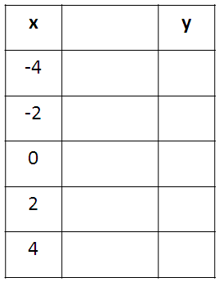

Example 6: Evaluate f(x) = 10x + 2 for the values given in the table.

What did we learn?

How do we write functions?
    - function notation is f(x)
    - read as "f of x"

How do we evaluate functions?
- Functions are like machines. They have an input and an output.
- Evaluate means solve!
- We "solve" functions by substituting (plug in) an input (x) value into our function. Our answer is the output (f(x)).
- We will always be given a function rule.A function rule is an equation that establishes the relationship between the domain (input or x) and the range (output or y).

