Name ______________________________
Math 8: Function Tables and Graphs
Directions: Fill in the blanks below as you watch the video.

Example #1: f(x) = x - 3
table:  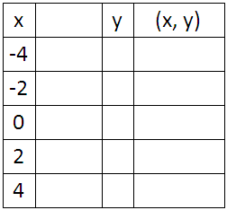 | 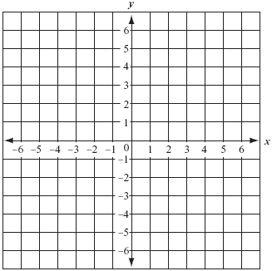 graph:

You Try!: f(x) = x / 2
table: | graph:  