Name _________________________
Math 8: Slope-Intercept Form

Directions: Fill in the blanks below as you watch the video.
Coco’s Carwash
# of cars |  | cost

Equation:  y = _____________________  Based on the graph, what is  the slope? _______  At what number does the line  cross the y-axis in the graph?  _______ | Graph: | 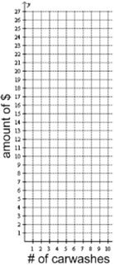

New Idea: y-intercept
The y-intercept is the ______ where the _______ crosses the ____________.
How are the slope and y-intercept related to the equation of
Coco’s Carwash’s new business plan?
Equation: ________________________
Slope = _______ y-Intercept = _____

New Idea: Slope-Intercept Form
y = ___________________
What does “m” mean? ________________
What does “b” mean? ________________

Super-Duper Important!
Slope-Intercept Form:
y = mx + b

_______ ______________
Identify the slope and y-intercept from each equation below.
- y = 2x - 1 slope = _____ y-intercept = _____
- y = -1/3 x slope = _____ y-intercept = _____
- y = x + 4 slope = _____ y-intercept = _____
- y = -6x - 5 slope = _____ y-intercept = _____

