**Name ___________________________**

**Math 8: Graphing Linear Equations**

***Directions: Fill in the blanks below as you watch the video.***

**Steps for Graphing Linear Functions**

1. Solve the equation for y.
2. Identify the slope & the y-intercept.
3. Graph the y-intercept.
4. Use the slope to graph another point on the line.
5. Connect the two points with a line.

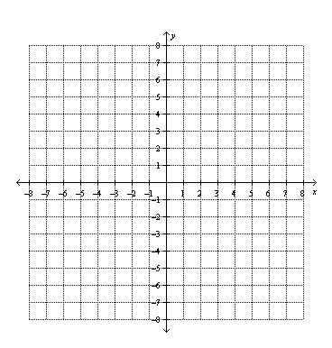

**Example 1:** Graph **.**

slope = ______

y-intercept = ______

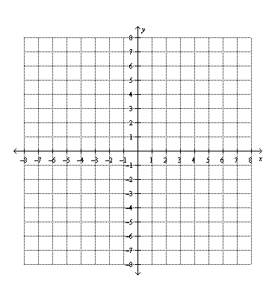

**You Try 1:** Graph 

slope = ______

y-intercept = ______

**Example 2:** Graph **.**



slope = ______

y-intercept = ______

**You Try 2:** Graph4*x* + 2*y* = 8



slope = ______

y-intercept = ______