Name ___________________________

Math 8: Different Representations of Linear Equations
Directions: Fill in the blanks below as you watch the video.
When comparing different representations, look at the __________ and _______________ for each one.

Example 1:
Does the table below represent the linear function y = 4x?

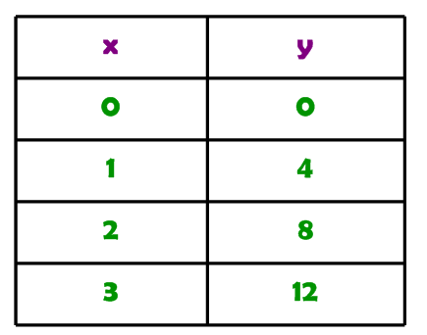 Equation:
slope = _________

y-intercept = ________

Table:
slope = _________

y-intercept = ________

You Try 1:
Does the table below represent the linear function y = 2x – 1?
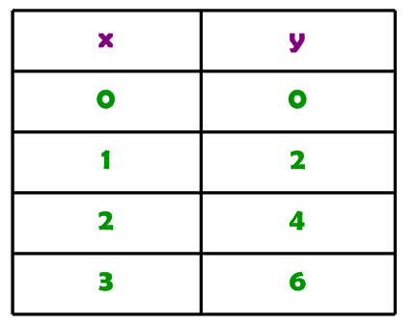
Equation:
slope = _________

y-intercept = ________

Table:
slope = _________

y-intercept = ________

Example 2:
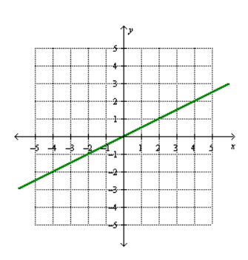Does the graph represent the linear function y = 4x?

Equation:
slope = _________

y-intercept = ________

Graph:
slope = _________

y-intercept = ________

You Try 2:
Does the graph below represent the linear function y = 2x - 1?

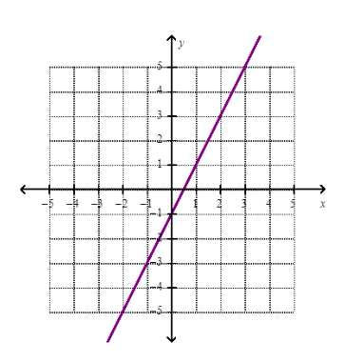 Equation:
slope = _________

y-intercept = ________

Graph:
slope = _________

y-intercept = ________

Example 3: Do the table and graph represent the same linear function?
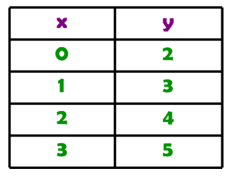
Table:
slope = _________

y-intercept = _______

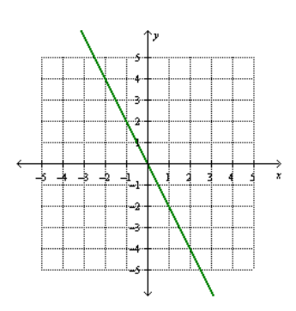

Graph:
slope = _________

y-intercept = ________

You Try 3:
Do the table and graph represent the same linear function?
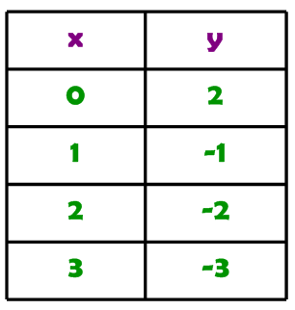
Table:
slope = _________

y-intercept = _______

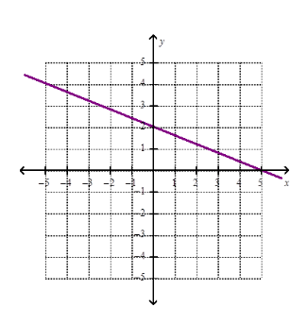
Graph:
slope = _________

y-intercept = ________

