Find the slope of the line for each pair of points.

1. (1, 0) and (3, 6) 2. (2, -1) and (6, 1)

Find the slope and y-intercept for the following equations.

3. y = 5x – 7 4. y = -2x + 4

Slope ___ slope ___

y-intercept ___ y-intercept ___

5. y = x 6. y + 3x = 8

Slope ___ slope ___

y-intercept ___ y-intercept ___

Look back at the equations for #3-6 to answer the following.

7. Which equation has the steepest graph? __________

8. Which equation has the flattest graph? ___________

9. Which equation(s) have graphs that slant upwards from left to right?

10. Write an equation of a graph that crosses the y-axis at a higher point than the equation y = 2x + 1.

Write an equation in slope intercept of a line with the following.

11. slope -1; y-intercept at (0, 5) 12. slope 2; y-intercept at (0,-8)

Write the following in slope-intercept form.

13. 2x – 5y = 25 14. -2x = y - 14

Identify the slope and y-intercept and graph the following equations.

15. y = ½ x – 3 16. 2x + 4y = 8

Slope = ___________ Slope = ___________

Y-Intercept = __________ Y-Intercept = __________

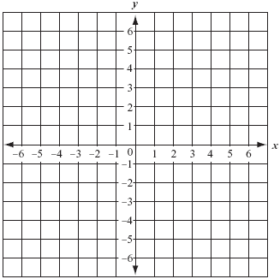



Write an equation for the following lines.



17. 18.

Slope = _________ Slope = _________

Y-Intercept = _______ Y-Intercept = _______

Equation = __________ Equation = __________

Identify the following tables as linear or nonlinear. If linear, write the equation for the table of values in slope-intercept form.

|  |  |  |  |  |  |  |  |  |  |  |  |  |  |  |  |  |  |  |  |  |  |
| --- | --- | --- | --- | --- | --- | --- | --- | --- | --- | --- | --- | --- | --- | --- | --- | --- | --- | --- | --- | --- | --- |
| 19.  Circle one: Linear Nonlinear  If linear, equation ______________   |  |  | | --- | --- | | x | y | | 1 | 1 | | 3 | 9 | | 4 | 13 | | 6 | 21 | | 20.  Circle one: Linear Nonlinear  If linear, equation ______________   |  |  | | --- | --- | | x | y | | 1 | 1 | | 2 | 3 | | 3 | 5 | | 5 | 7 | |

21. Identify the following lines as **parallel, perpendicular or neither**.

1. y = 3x + 2 b. 2x + 4y = 8

x + 3y = 6 2x + 4y = 16

22. Write the **slope of the line parallel** to the line passing through (-1, -2) and (3, 10).

23. Write the **slope of a line that is perpendicular** to the line passing through (-1, 4) and (4, 11).