Linear equations test unit 4 Name ______________

Find the slope of the line for each pair of points.

1. (3, 4) and (2, 7) 2. (-3, 4) and (5, 6)

Find the slope and y-intercept for the following equations.

3. y = 5x + 4 4. y = -2x – 3 5. y = -x + 7

Slope ___ slope ___ slope ___

y-intercept ___ y-intercept ___ y-intercept ___

6. y = x – 5 7. y = 2x 8. y - 4x = 5

Slope ___ slope ___ slope ___

y-intercept ___ y-intercept ___ y-intercept ___

Look back at the equations for #3-8 to answer the following.

9. Which equation has the steepest graph? __________

10. Which equation has the flattest graph? ___________

11. Which equation(s) have graphs that slant upwards from left to right?

12. Write an equation of a graph that crosses the y-axis at a higher point than the equation y = 3x + 2.

Write an equation in slope intercept of a line with the following.

13. slope -2; y-intercept at (0, -2) 14. slope 1; y-intercept at (0,5)

Write the following in slope-intercept form.

15. 3x – 5y = 25 16. -3x = y – 5

Identify the slope and y-intercept and graph the following equations.

17. y = -5x – 3 18. 2x + 5y = 10

Slope = ___________ Slope = ___________

Y-Intercept = __________ Y-Intercept = __________

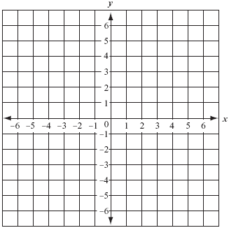

Identify the slope and y-intercept for the following lines then write the equation in slope-intercept form.



19. 20.

Slope = _________ Slope = _________

Y-Intercept = _______ Y-Intercept = _______

Equation = __________ Equation = __________

Identify the following tables as linear or nonlinear. If linear, write the equation for the table of values in slope-intercept form.

|  |  |  |  |  |  |  |  |  |  |  |  |  |  |  |  |  |  |  |  |  |  |
| --- | --- | --- | --- | --- | --- | --- | --- | --- | --- | --- | --- | --- | --- | --- | --- | --- | --- | --- | --- | --- | --- |
| 21.  Circle one: Linear Nonlinear  If linear, equation ______________   |  |  | | --- | --- | | x | y | | 2 | 3 | | 4 | 6 | | 6 | 9 | | 8 | 6 | | 22.  Circle one: Linear Nonlinear  If linear, equation ______________   |  |  | | --- | --- | | x | y | | 1 | 1 | | 2 | 4 | | 4 | 10 | | 5 | 13 | |

23. Identify the following lines as **parallel, perpendicular or neither**.

1. y = 4x + 4 b. x + 2y = 8

x + 4y = 8 4x + 4y = 16

24. Write the **slope of the line parallel** to the line passing through (0, -1) and (5, 5).

25. Write the **slope of a line that is perpendicular** to the line passing through (-2, 5) and (3, 6).