1. Below is a table showing the temperature of soup heating in a pot over time.

1. Complete the table below.

|  |  |  |  |  |  |
| --- | --- | --- | --- | --- | --- |
| Time (minutes) | 0 | 1 | 2 | 3 | 4 |
| Temperature (in degrees Fahrenheit) | 60 | 66 | 72 | 78 | 84 |

b. Write a linear equation relating time *T* and temperature of the soup *S*.

c. Write a NOW - NEXT equation that shows how the temperature changes with each additional

minute.

2. A local carnival charges an entrance fee of $14. In addition, they charge $0.25 for each ride. Which of the following equations could be used to determine the cost *C* of attending the carnival if you plan to ride *r* rides?

C = 14.25r C = 14 + 0.25r C = 14r + 0.25

3. Graph the equation. *y* – 3 = –(x – 1)



4. A student finds the slope of the line between (4, 3) and (-2, -2). She writes $\frac{-2-4}{-2-3}$. What mistake did she make? Correctly solve the problem.

Error:

Solution worked out correctly:

5. Consider the line with a graph containing the points (-2, 3) and (3, 8).

1. Write the equation in slope-intercept form.
2. Is the point (-4, -1) on the graph of the line? Explain.
3. Give the coordinates of one other point (one that has not been used already) that will also be on this line. Explain how you know your point will be on the line.

6. Describe a similarity and a difference between the graphs*?*

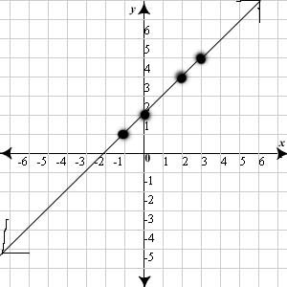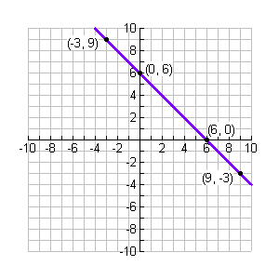

7. Jessica got her uncle to sponsor her for the swim-a-thon to raise money for her swim club. He said he would use the equation ***A*** = 10 + 0.5***s***, where ***A*** is the amount he will pay if Jessica swims ***s*** yards.

1. Identify the slope and y-intercept.

Slope:_________________ Y-Intercept: _________________

1. Explain the meaning of the slope and the y-intercept in this equation in terms of distance swam and the amount Jessica’s uncle will pay.

c. On the grid below, sketch a graph that indicates how much her uncle will pay as a function of the

distance that she swims.



Amount Uncle Pays

10

9

8

7

6

5

4

3

2

1

14

16

18

20

22

10

12

8

6

4

2

Distance (yards)

8. Find the rate of change. Explain what the rate of change means for this problem.

Rate of Change:_________________

Explanation:

Find the x-intercept and the y-intercept of the following equation.

9.) –x +6y = 12

X-Intercept:

Y-Intercept:

Y-Intercept:

Write an equation in slope intercept form for the line that is parallel to the given line and that passes through the given point.



10.) (-2, 8); y= -3x + 4

Write an equation in slope intercept form for the line that is perpendicular to the given line and that passes through the given point.



11.) (3, -2); y= x – 2

12. The number of eyes varies directly with the number of people in the room. There are 60 eyes in a room with 30 people.

a**.** Write an equation for the relationship between number of eyes and number of people.

1. How many eyes were they be with 36 people?

Is each equation a direct variation? If it is, find the constant of variation.

13. 3*x* + *y* = 4 14. *x* – 2*y* = 0

Yes/No Yes/No

K:__________ K:__________

|  |  |  |  |  |  |  |  |  |  |  |  |  |  |  |  |  |  |  |  |  |  |
| --- | --- | --- | --- | --- | --- | --- | --- | --- | --- | --- | --- | --- | --- | --- | --- | --- | --- | --- | --- | --- | --- |
| 15.  Circle one: Linear Nonlinear  If linear, equation ______________   |  |  | | --- | --- | | x | y | | -2 | 4 | | -1 | 5 | | 0 | 4 | | 1 | 5 | | 16.  Circle one: Linear Nonlinear  If linear, equation ______________   |  |  | | --- | --- | | x | y | | 4 | 5 | | 3 | 4 | | 0 | 1 | | -6 | -5 | |

Identify the following tables as linear or nonlinear. If linear, write the equation for the table of values in slope-intercept form.

17. The local candy store sells 4lb of candy for $3.99, while the grocery store down the street sells a 5lb bag of candy for $4.29.

1. What is the cost of one pound of candy at each location?

Candy store:______________ Grocery store: ______________

1. Write the equation to describe the cost of candy at each store if *c* is the cost and *p* is the number of pounds of candy purchased.

Candy store:___________________ Grocery store: ___________________

1. How does the cost of one pound of candy relate to the equations you write in part b?
2. If you spend $15 on candy, about how many pounds of candy can you purchase at each location? Which store offers the better buy and by how much?

Candy store:______________ Grocery store: ______________

Better buy?

18. Explain the error in the student’s work below and then find the correct equation.

$$Find the equation of a line that goes through the points \left(2, 5\right)and \left(-3, 15\right)$$

$$\frac{15-5}{-3-2}=-2$$

$$y=mx+b$$

$$-3=-2\left(15\right)+b$$

$$-3=-30+b$$

$$b=27$$

$$y=-2x+27$$

Error:

Correct equation: